Jupyter Notebook

1-3

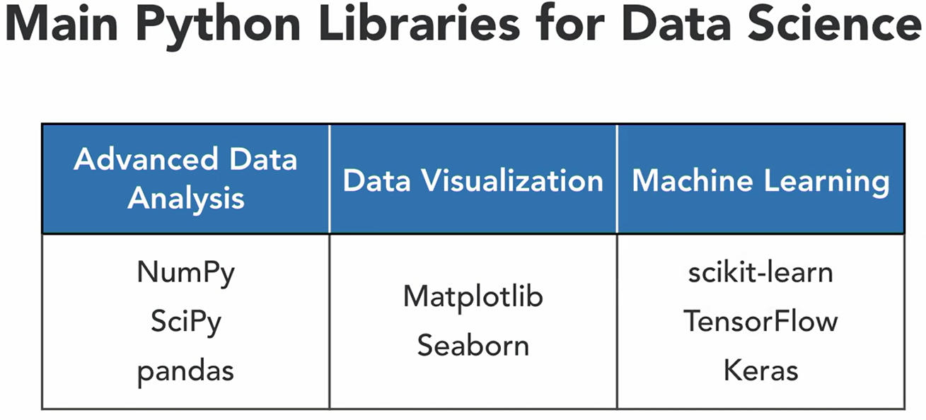

**2. Data Preparation Basics**

2-1 Filtering and selecting

给index赋值，选择指定行列，给指定行列赋值

2-2

Checking missing value：.isnull()

Filling in for missing value: .fillna(要填充的值) .fillna({0:0.1, 5:1.25}) :前是被替代的值, :后是新的填充值

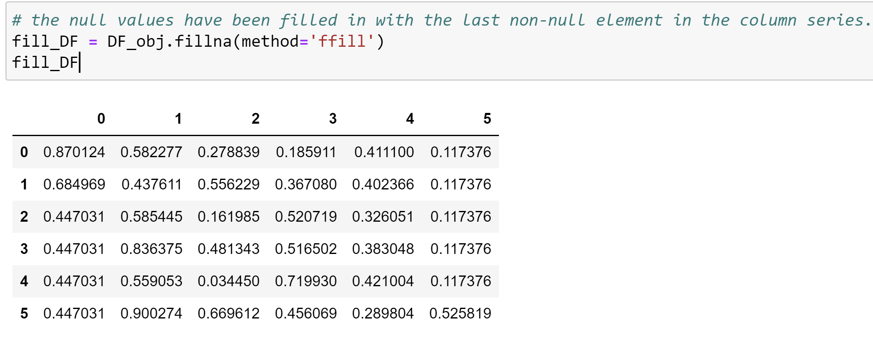

Counting missing value: .isnull().sum() 列

Filtering out missing values: .dropna() 默认行 .dropna(axis=1) drop列

2-3 Removing duplicates

.duplicated()

.drop_duplicates()

.drop_duplicates(['column 3'])

2-4 Concatenating and transforming

Concatenating based on the row indexes: pd.concat([DF_obj, DF_obj_2], axis=1) 增加行

Concatenating based on the column indexes: pd.concat([DF_obj, DF_obj_2]) 增加列

Dropping the rows: DF_obj.drop([0,2])

Dropping the columns: DF_obj.drop([0,2], axis=1)

concat

Join

Append

区别

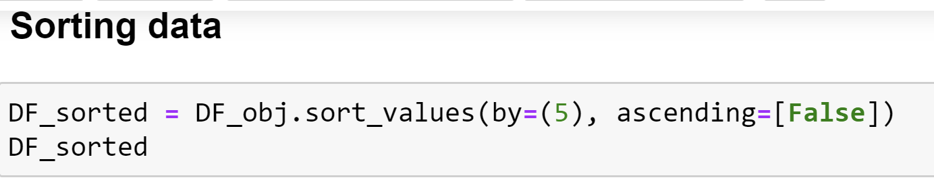

Column 5, return decreasing order

2-5 Grouping and aggregation

**3. Data Visualization 101**

3-1 The three types of data visualization

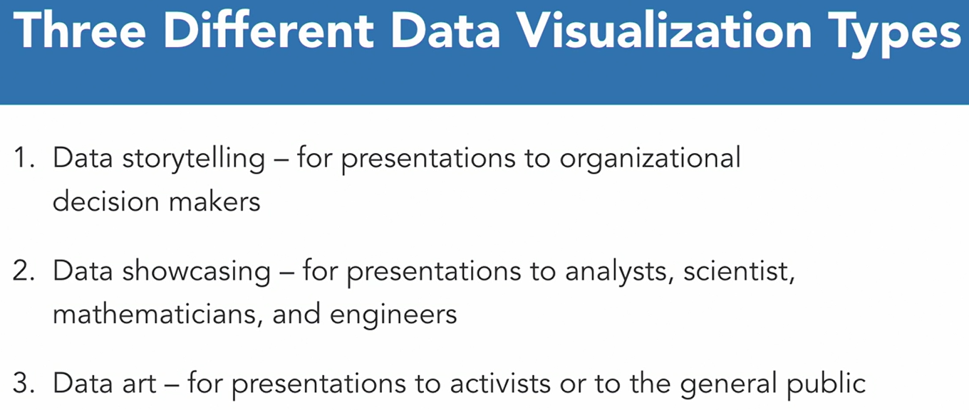

3-2 Selecting optimal data graphics

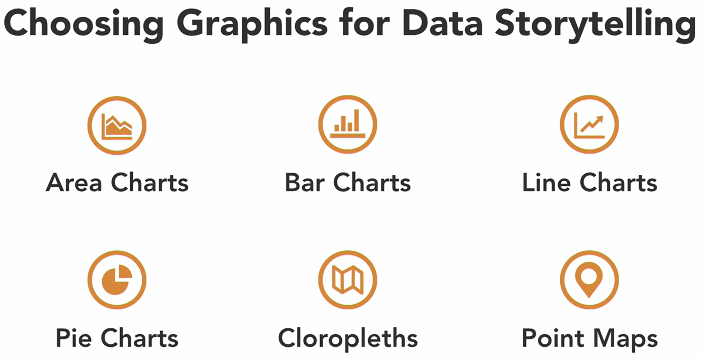

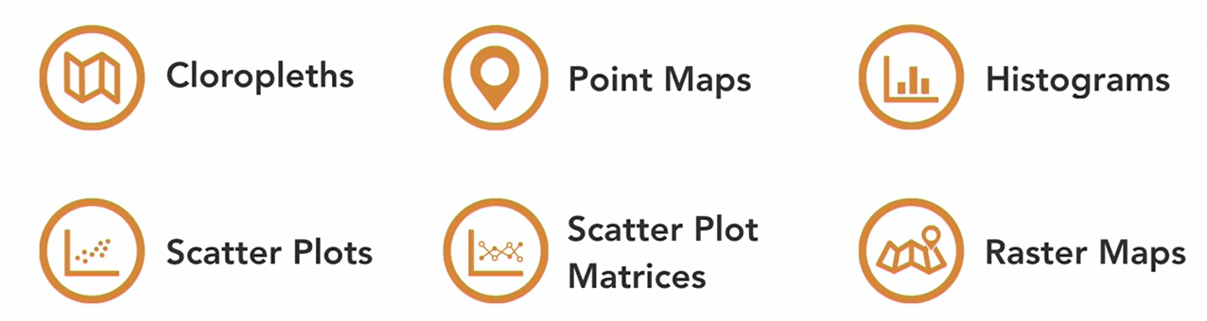

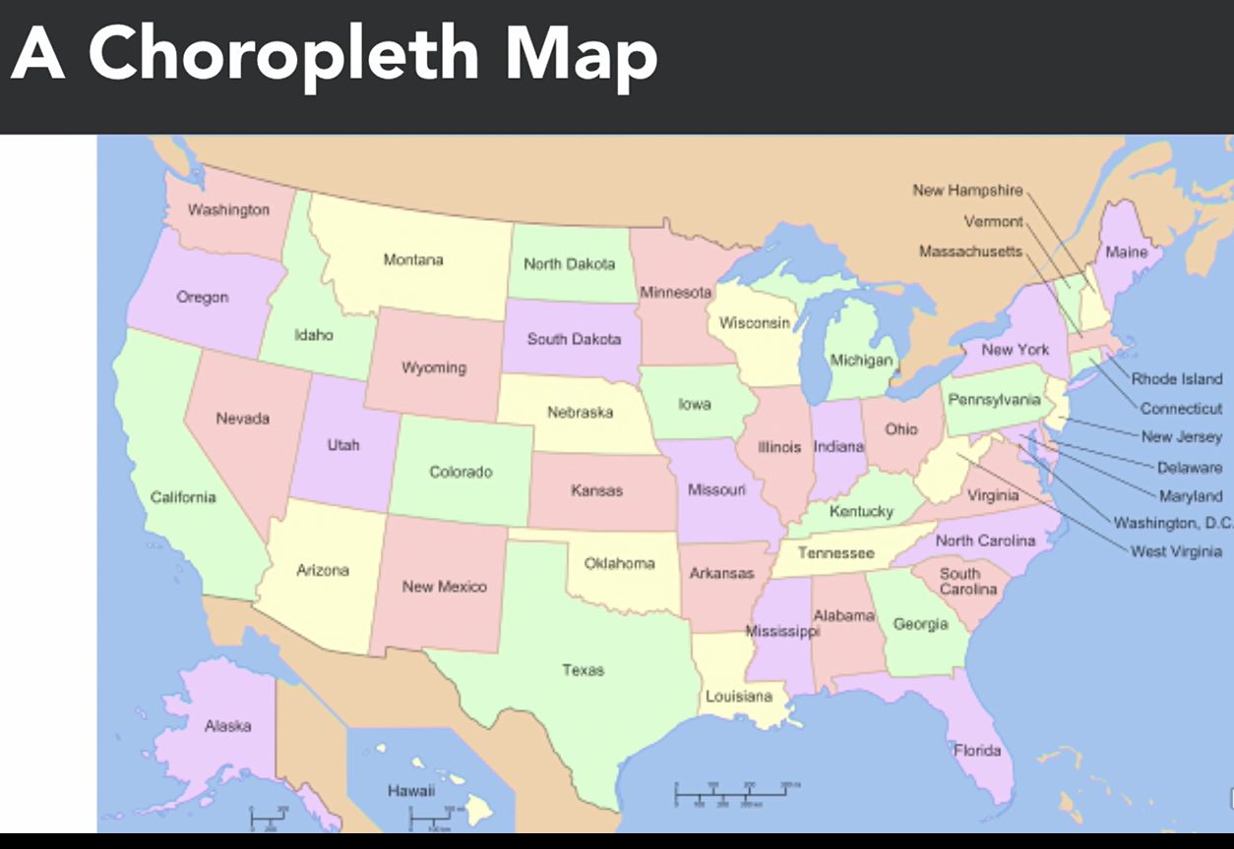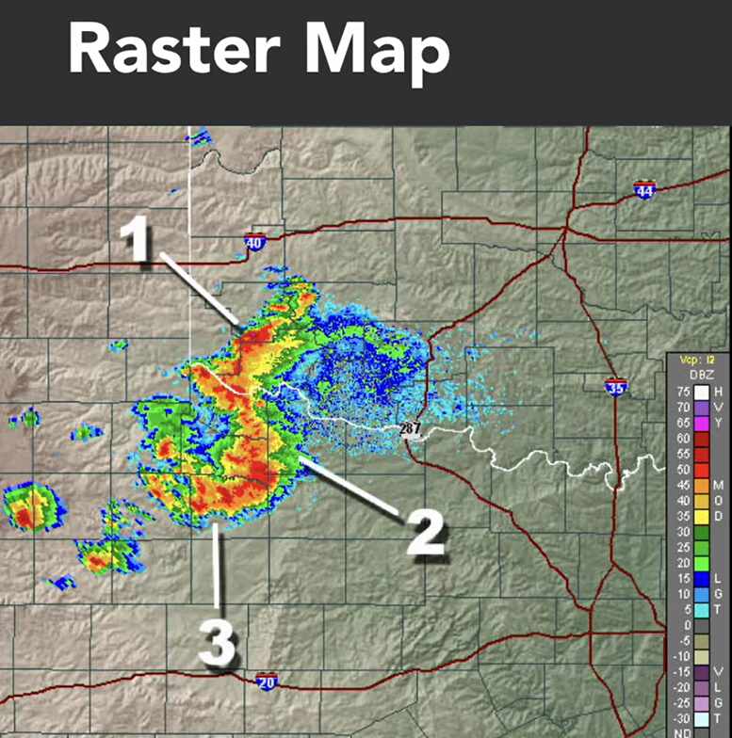

3-3 Communicating with color and context

**4.practical Data Visualization**

4-1 Creating standard data graphics

Identify the present working directory

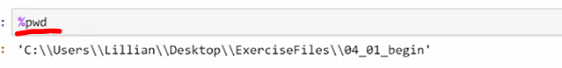

#### Plotting a line chart in matplotlib

plt.plot(x,y)

#### Plotting a line chart from a Pandas object

mpg = cars['mpg']

mpg.plot()

#### Creating a bar chart from a list

plt.bar(x,y)

#### Creating bar charts from Pandas objects

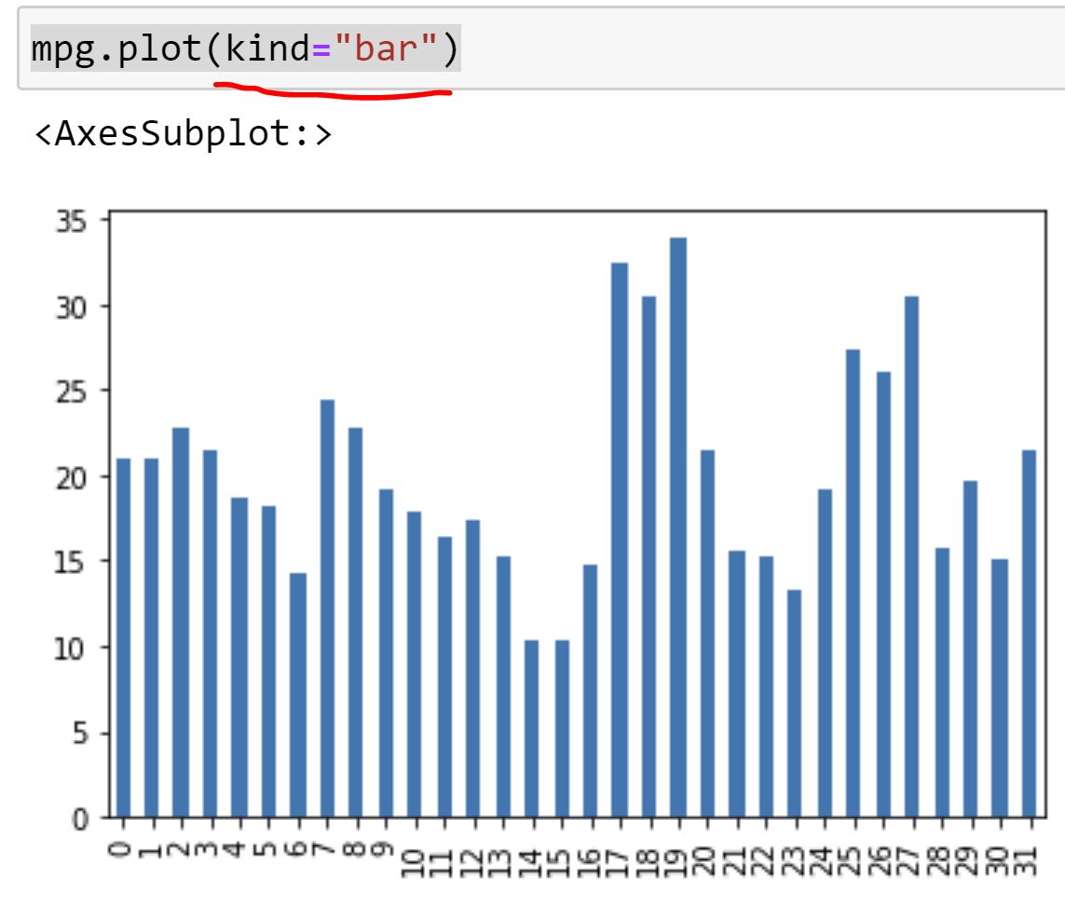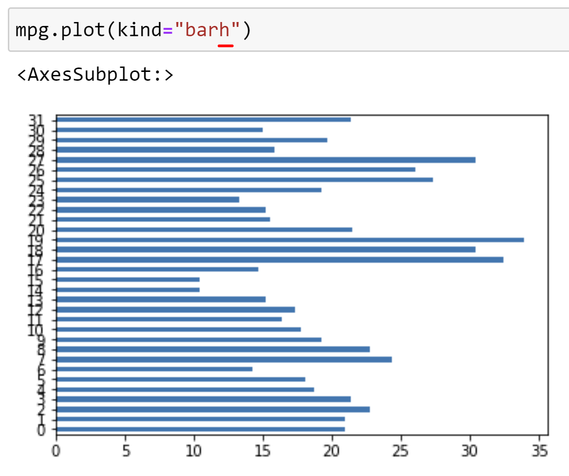

### *Creating a pie chart*

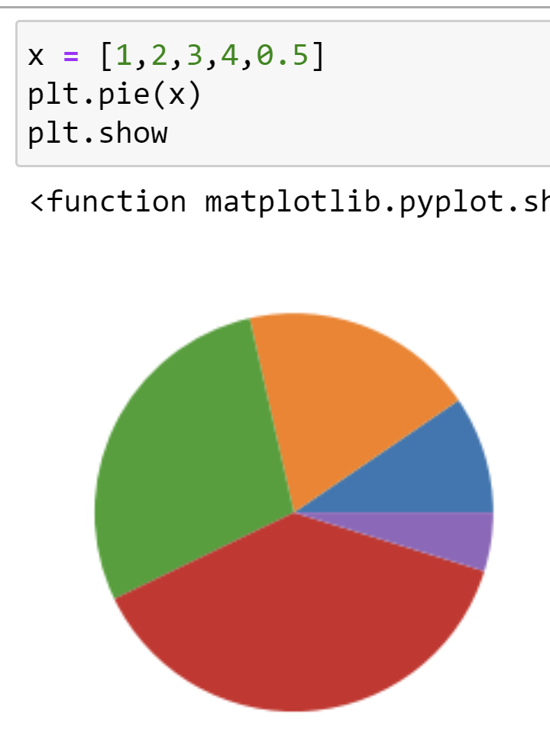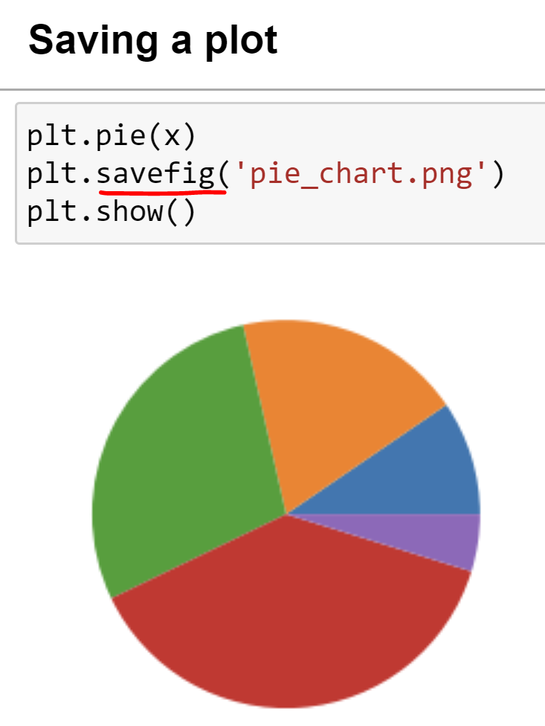

4-2 Defining elements of a plot

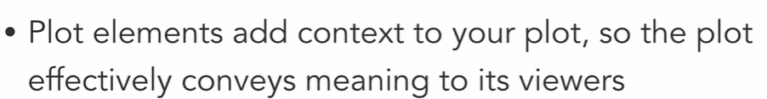

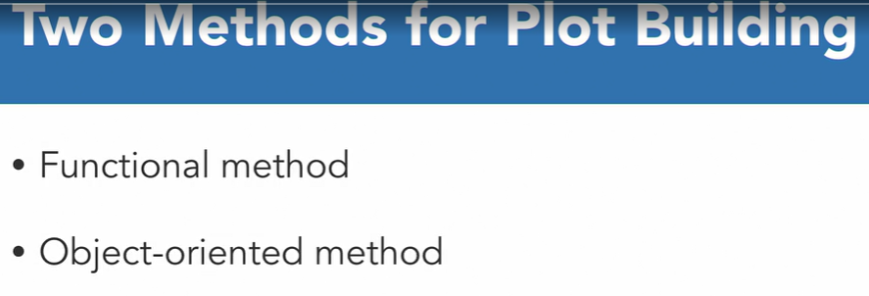

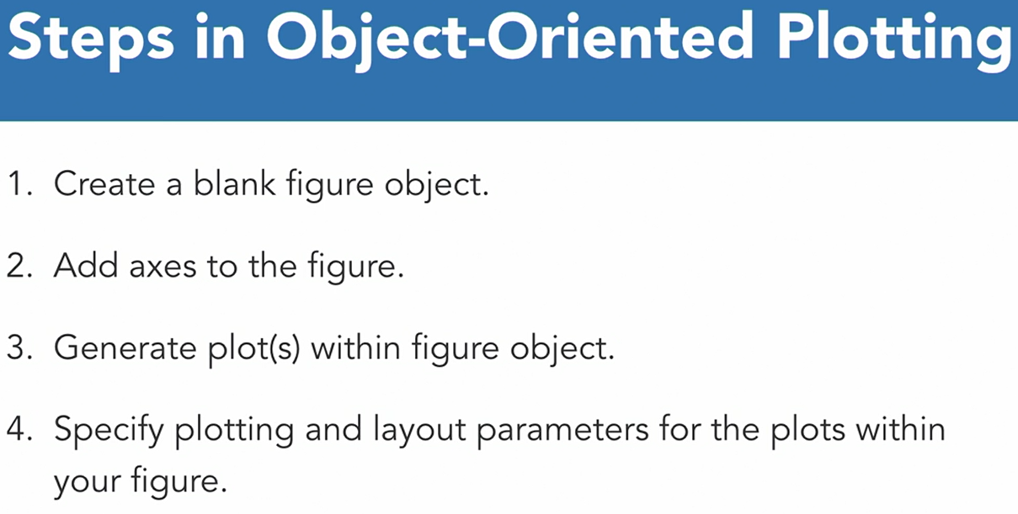

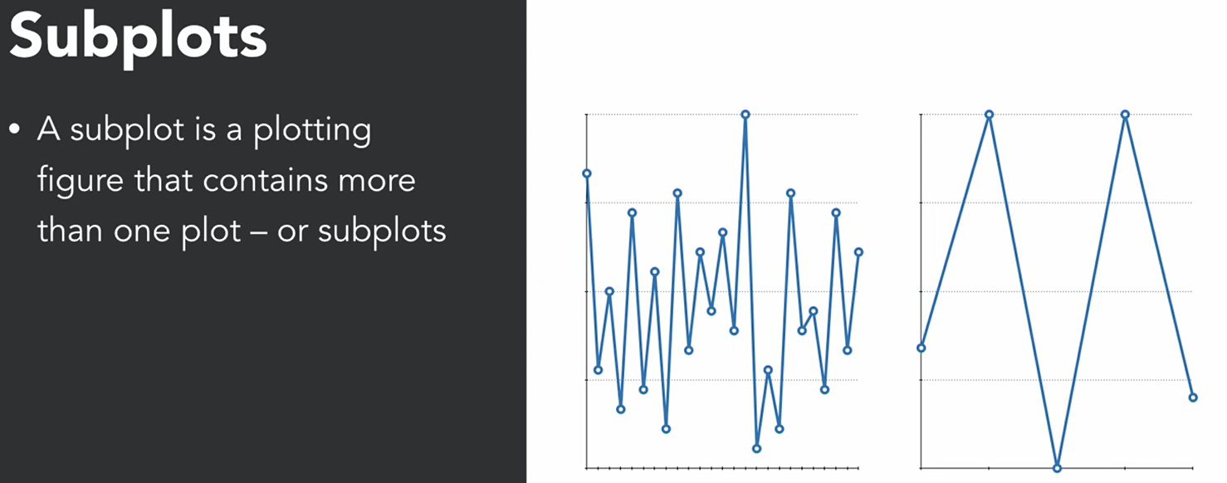

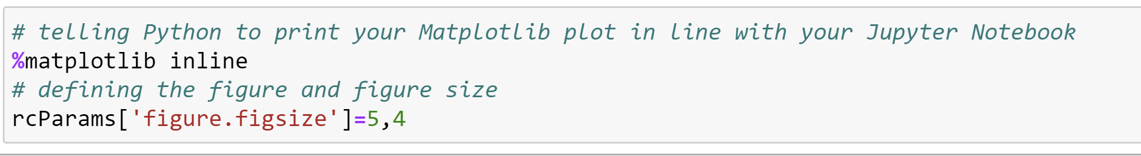

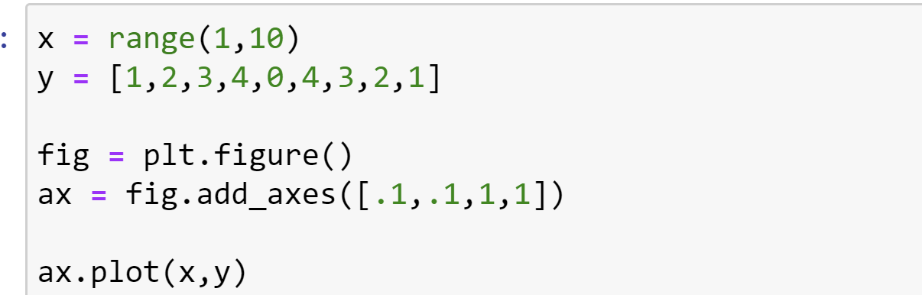

add_axes()方法需要一个由4个元素组成的list对象，分别对应图形的左、底、宽、高。每个数字必须在0和1之间。

**ax= fig.add_axes([0.8,0,1,1])**，改变第一个参数为0.8，图像从左往右移动了80%，只能看到图片左边20%的部分。

改动为**ax = fig.add_axes([0,0.8,1,1])**，改变第二个参数为0.8，图像从下往上移动了80%。

**ax = fig.add_axes([0,0,0.5,1])**，改变第三个参数为0.5，图像在宽度方向上压缩了一半，且位置靠在最左边。

改动为**ax = fig.add_axes([0,0,1,0.5])**，改变第四个参数为0.5，图像在高度方向上压缩了一半，且位置靠在最下边。

利用这四个参数，我们可以在原来设定的画板上的任意位置进行贴图。

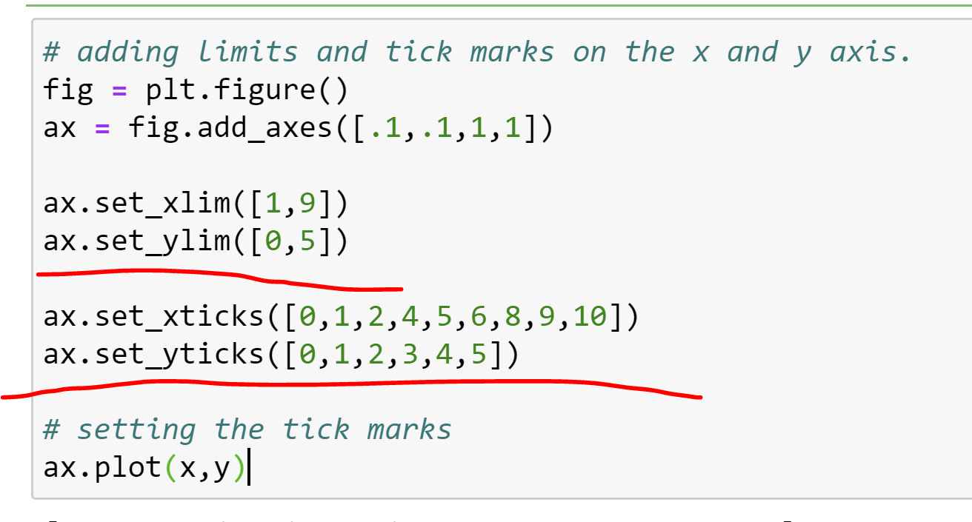

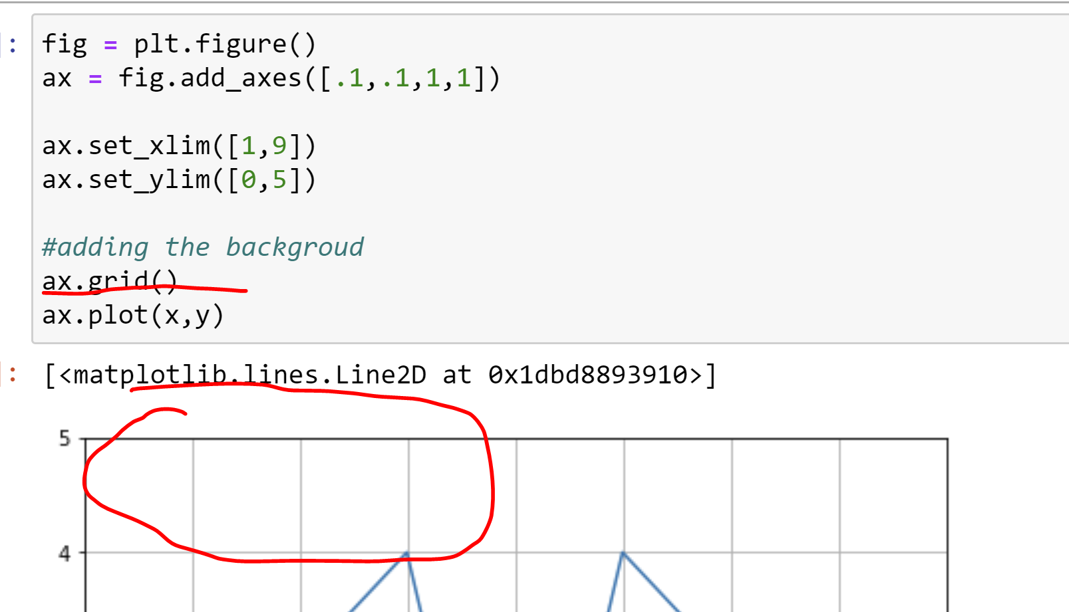

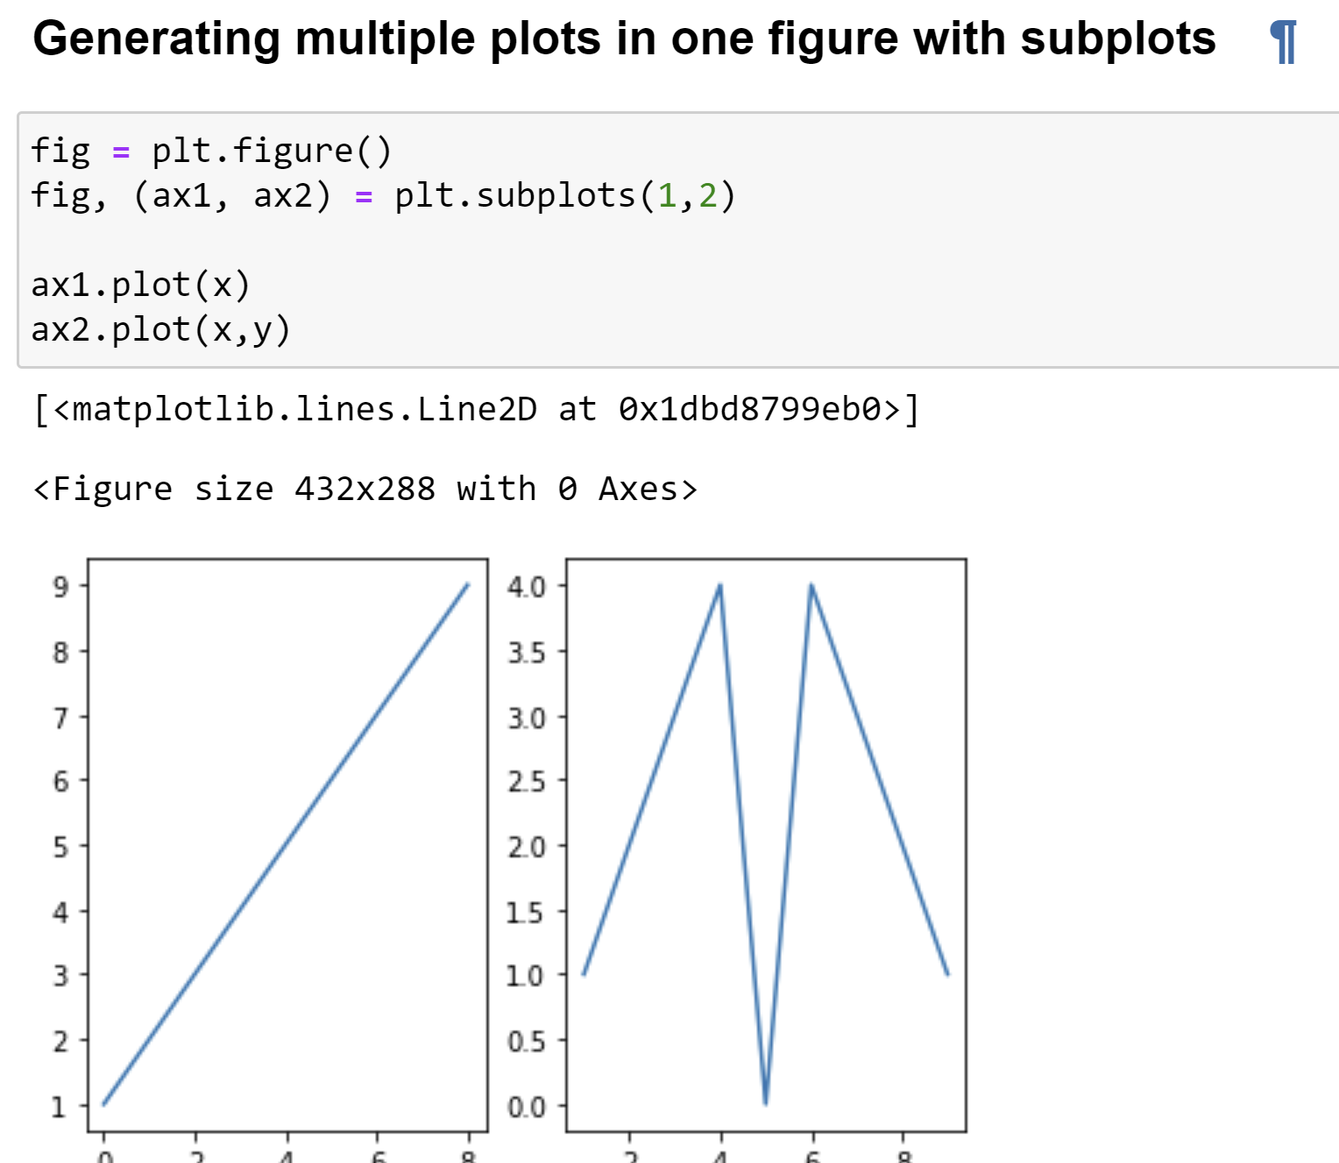

4-3 Plot formatting

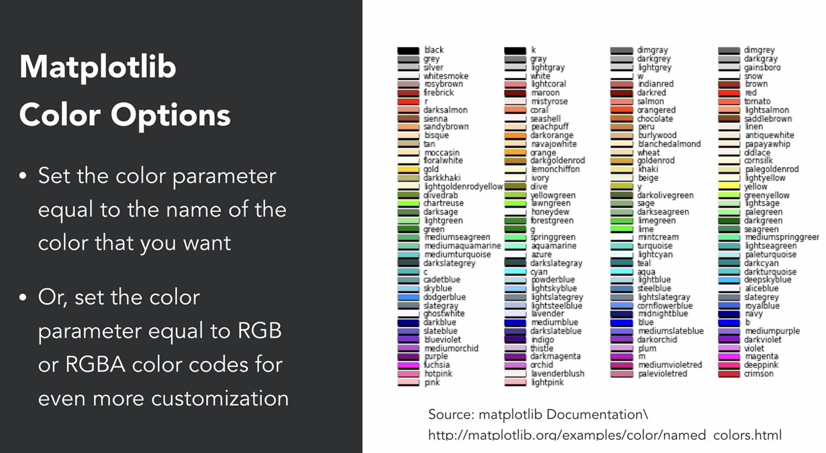

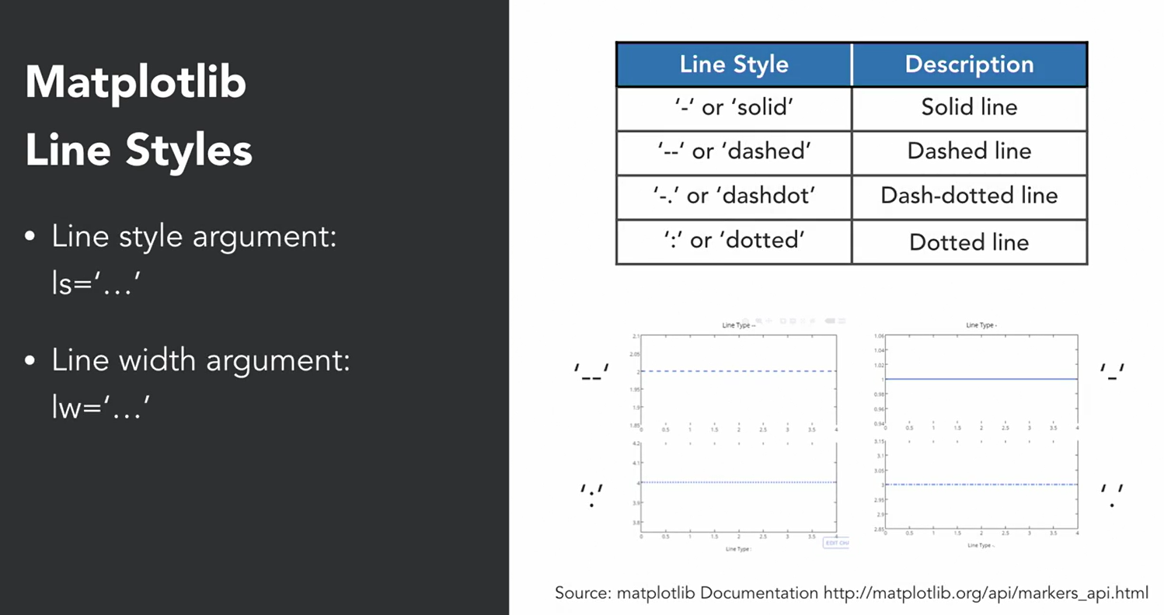

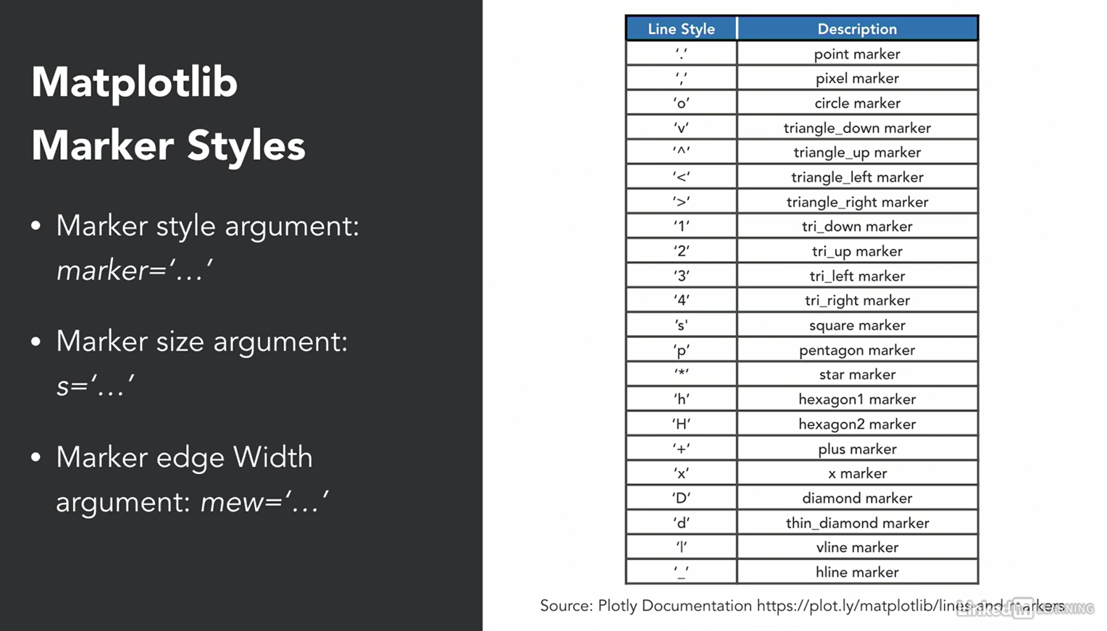

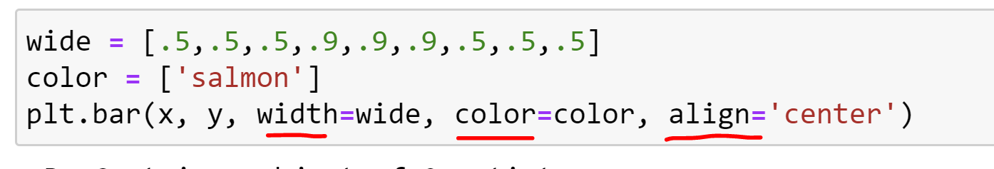

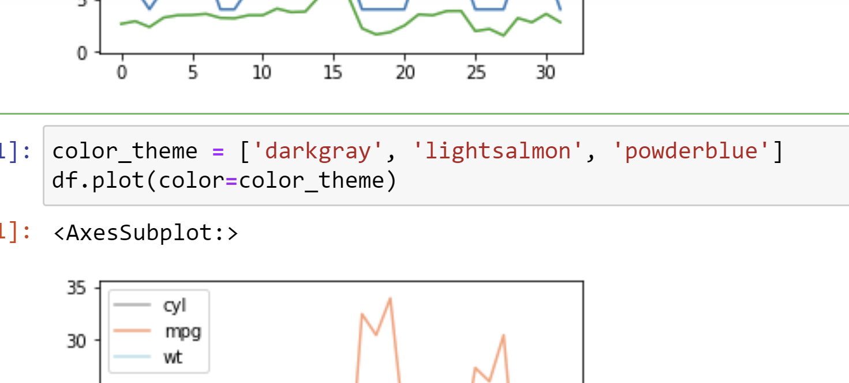

#### changing colors based on the GB code

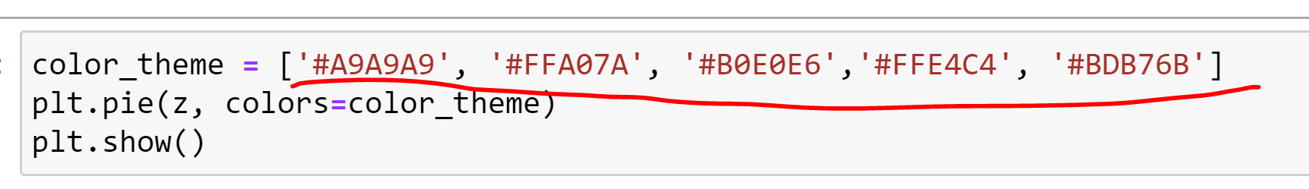

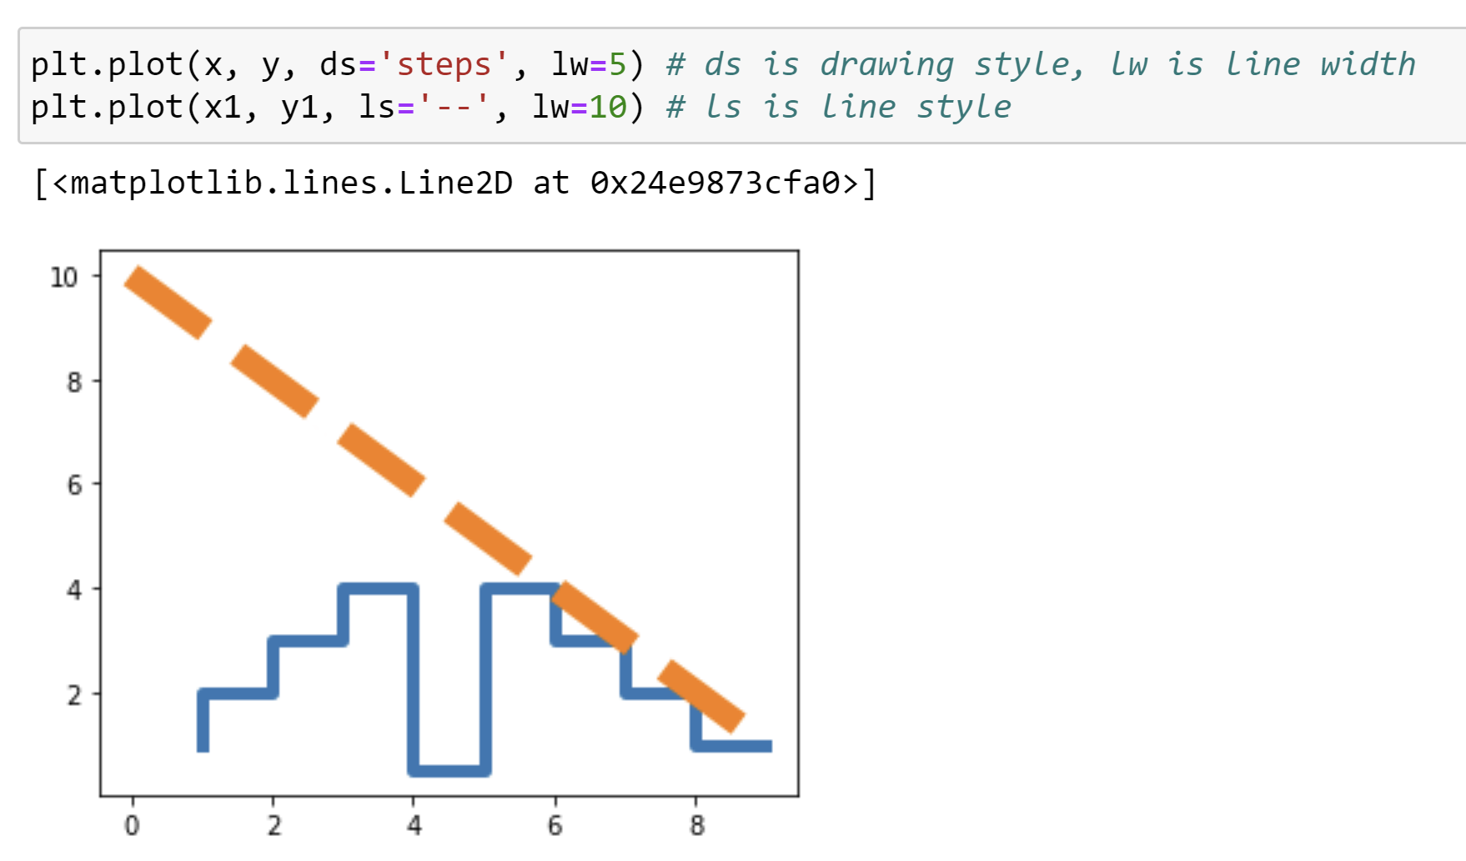、

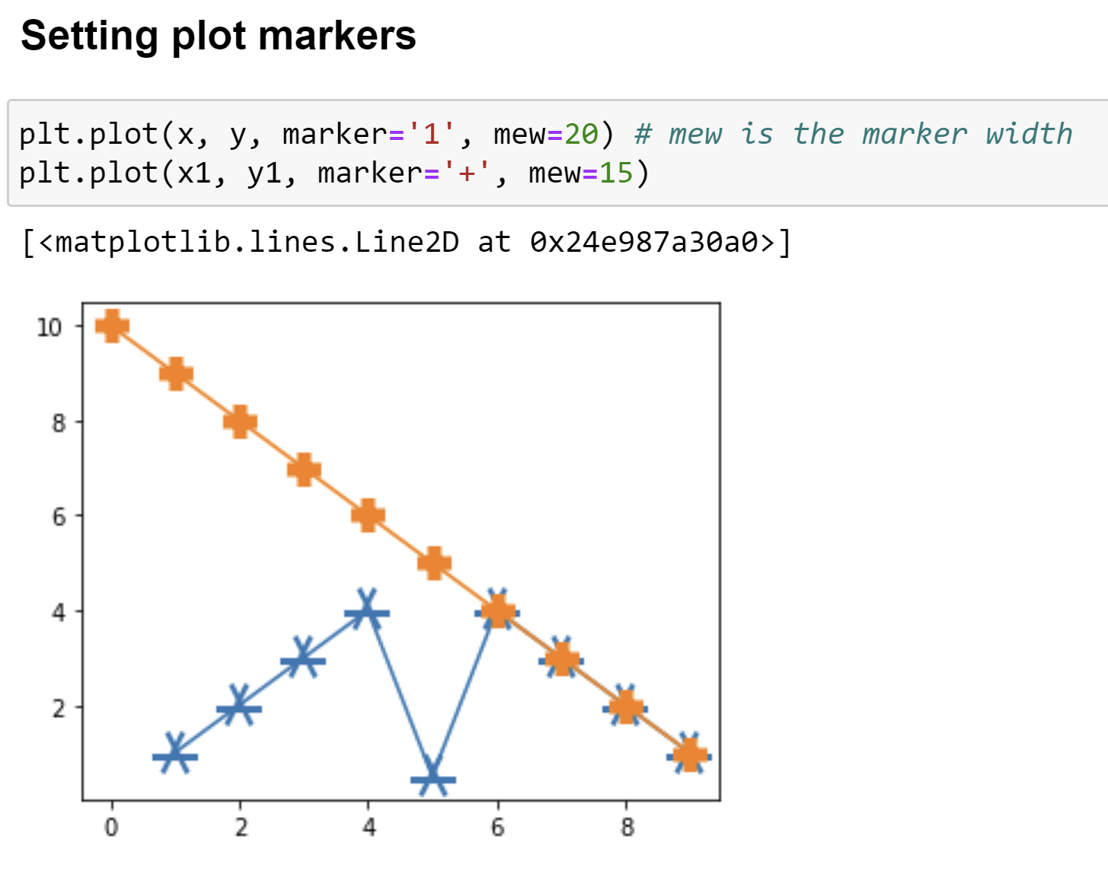

4-4 Creating labels and annotations

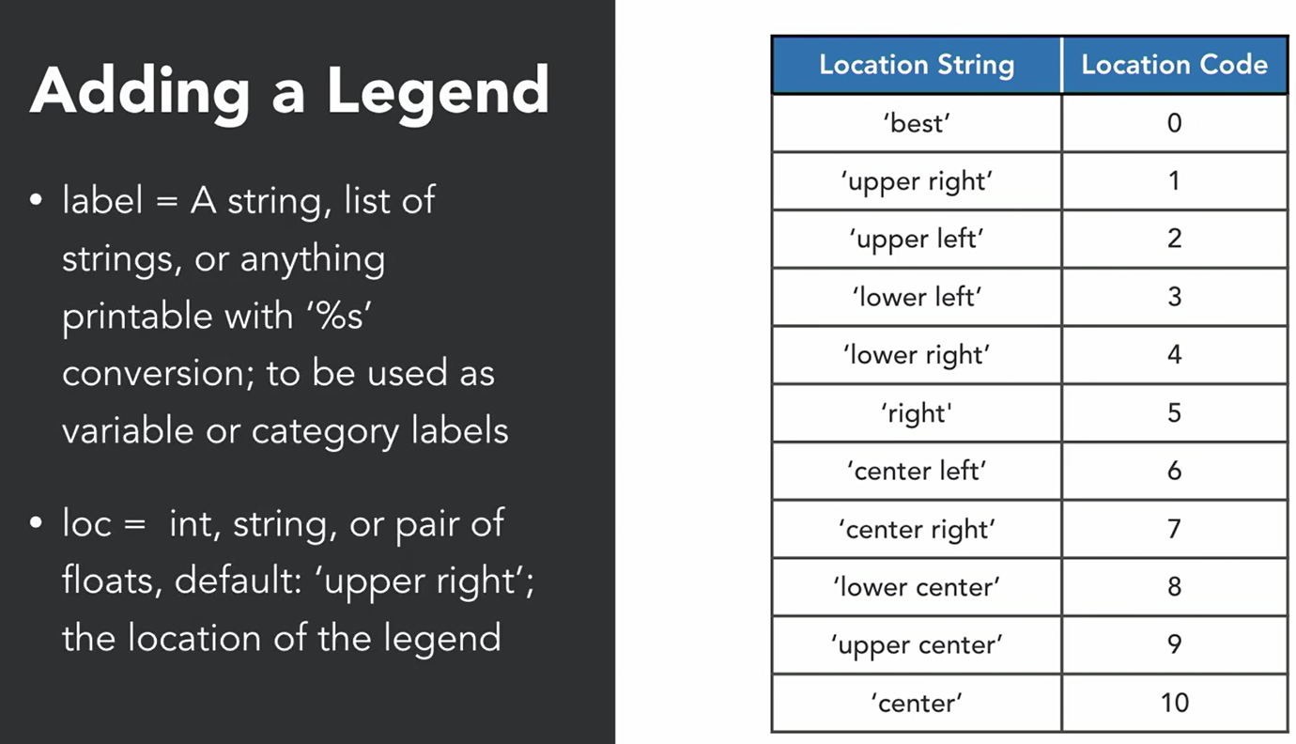

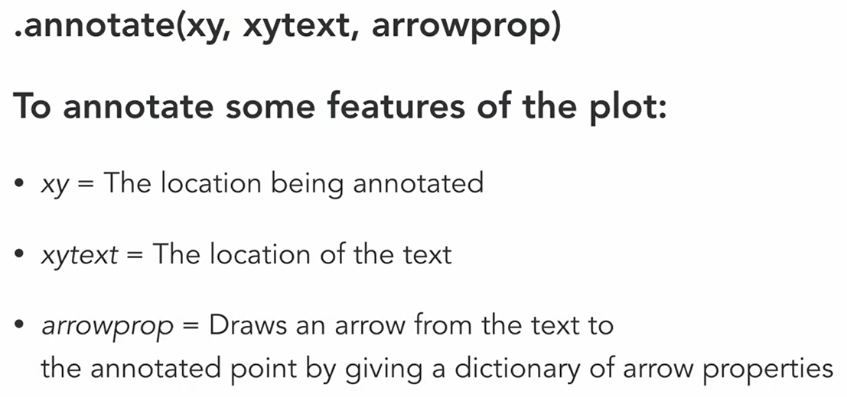

The functional method

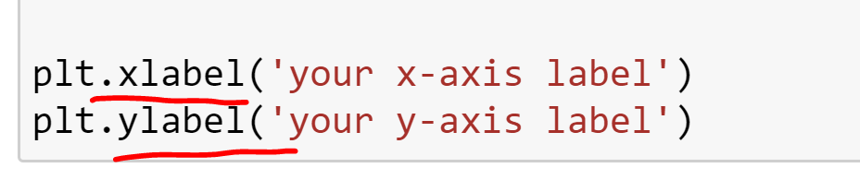

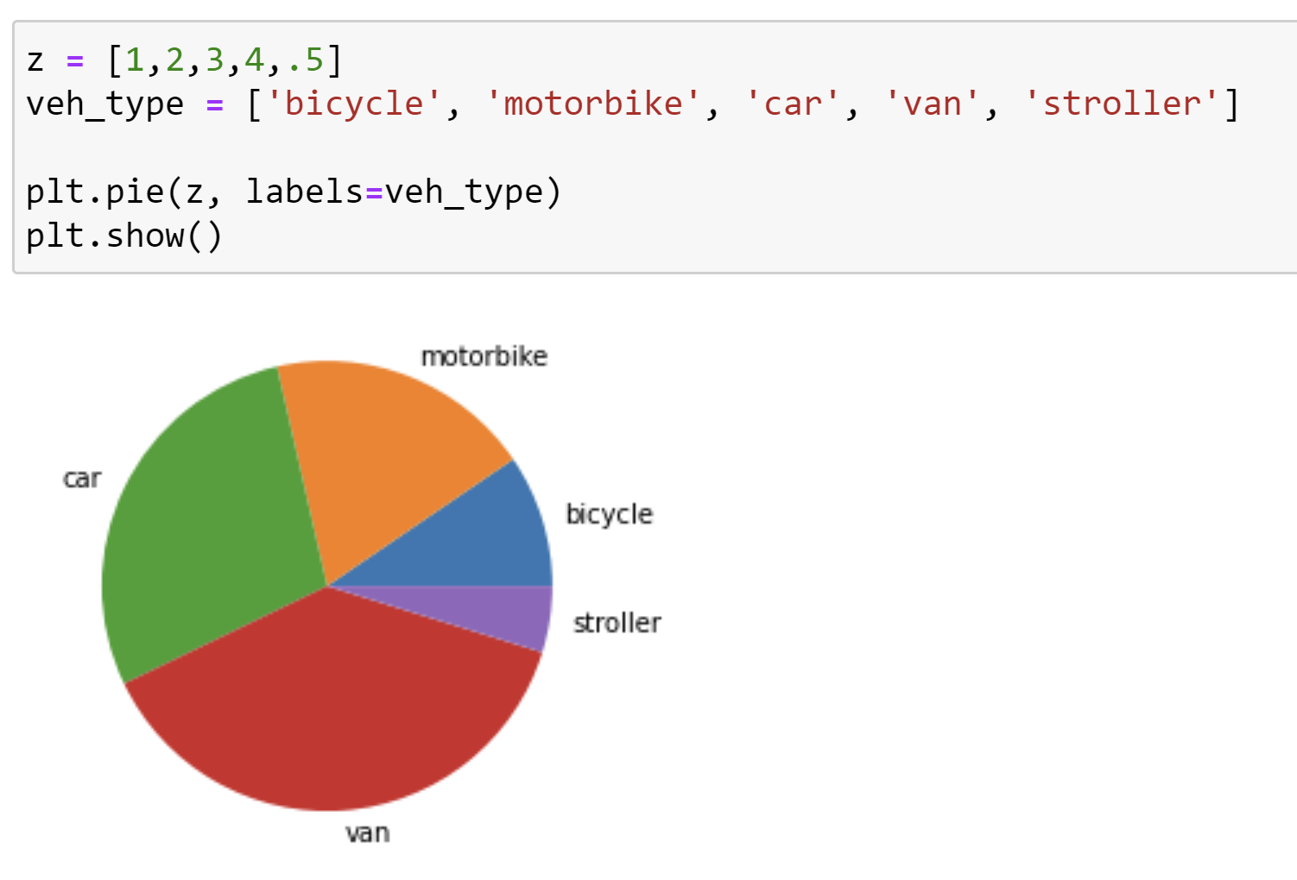



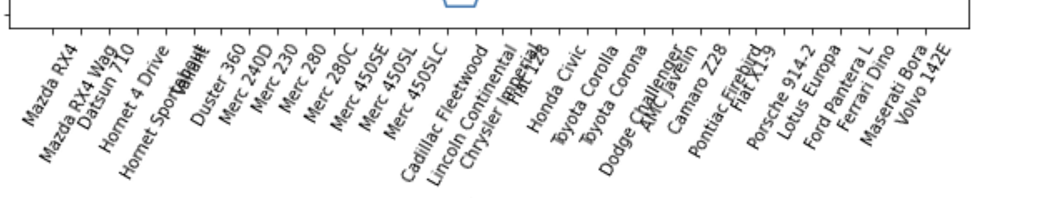

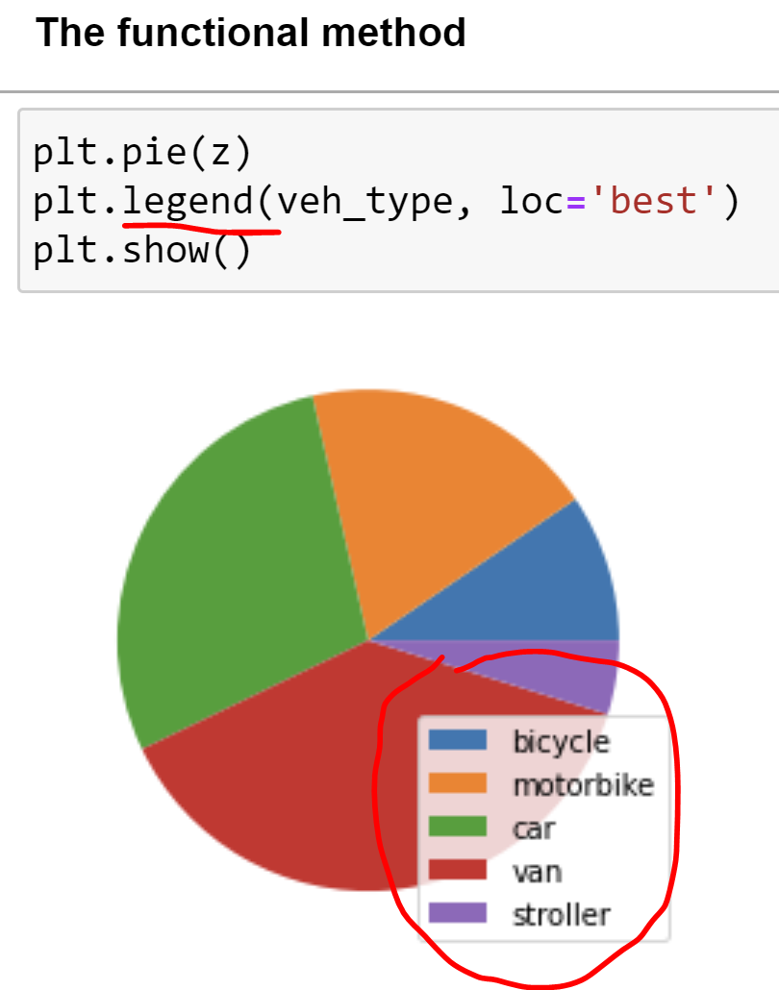

#### The object-oriented method

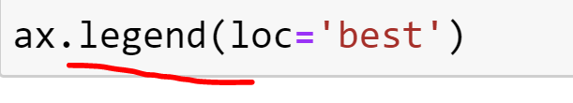

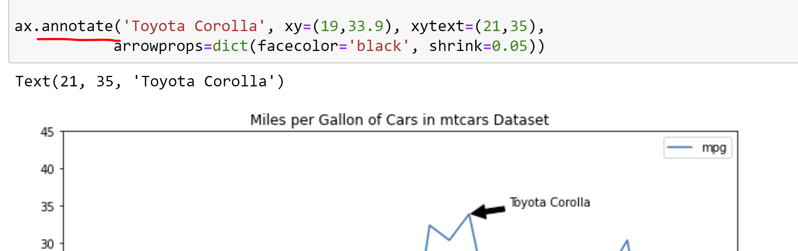

4-5 Visualizing time series

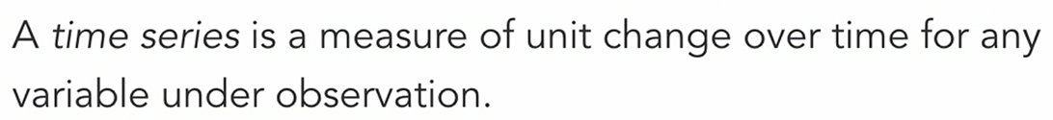

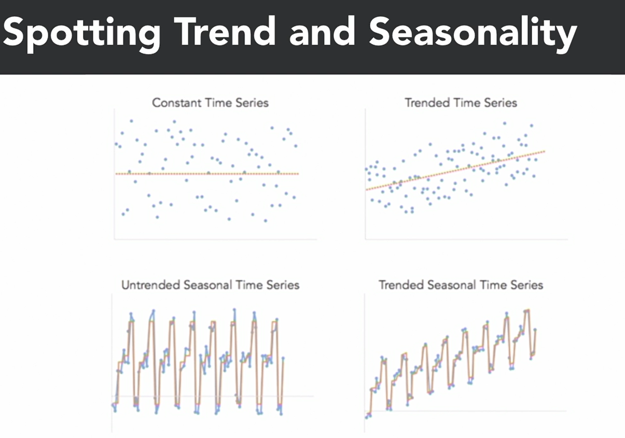

**Constant Time Series:** you are not seeing any trends or changes in the variable over time.

**Trended Time Series:** you can see a net increase or decrease in time series variable over time.

**Untrended Seasonal Time Series:** the variable is increasing and decreasing according to the season of the year. But you are not seeing a net change in the average value of time series.

**Trended Seasonal Time Series:** the variable increases and decreases with the season, but there is a net gain in the variable over time.

4-6 Creating statistical data graphics

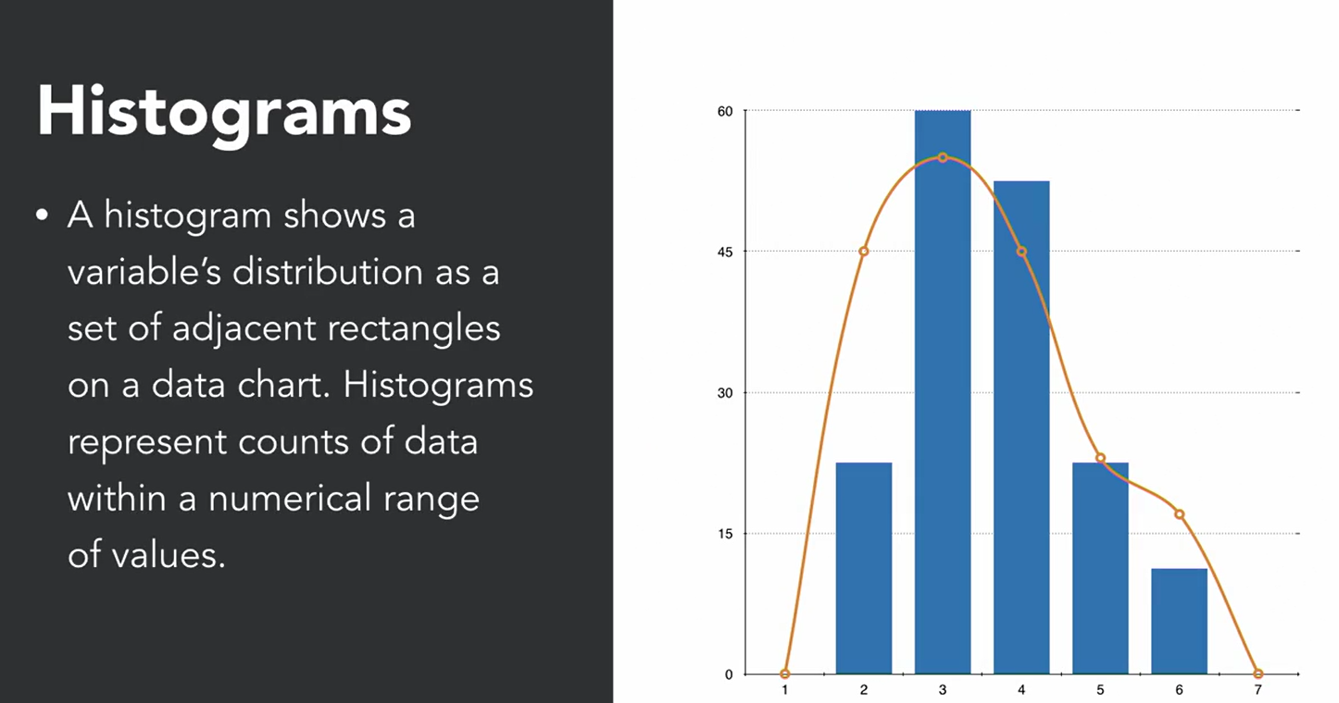

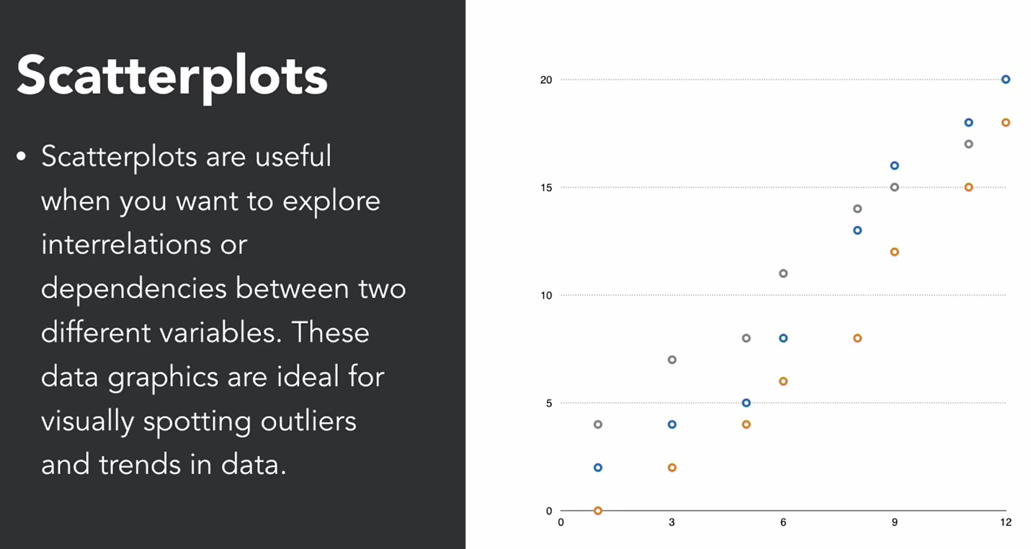

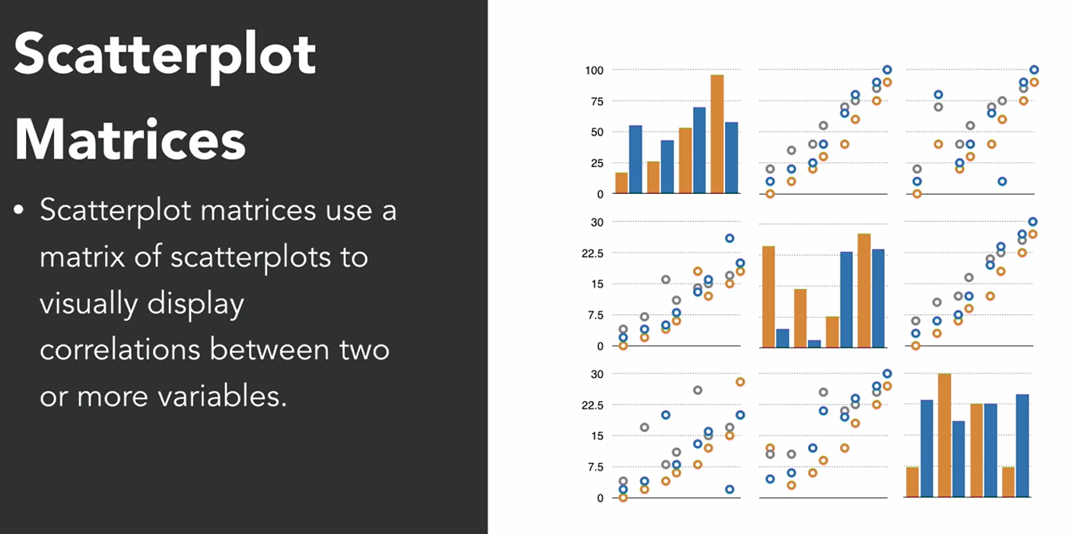

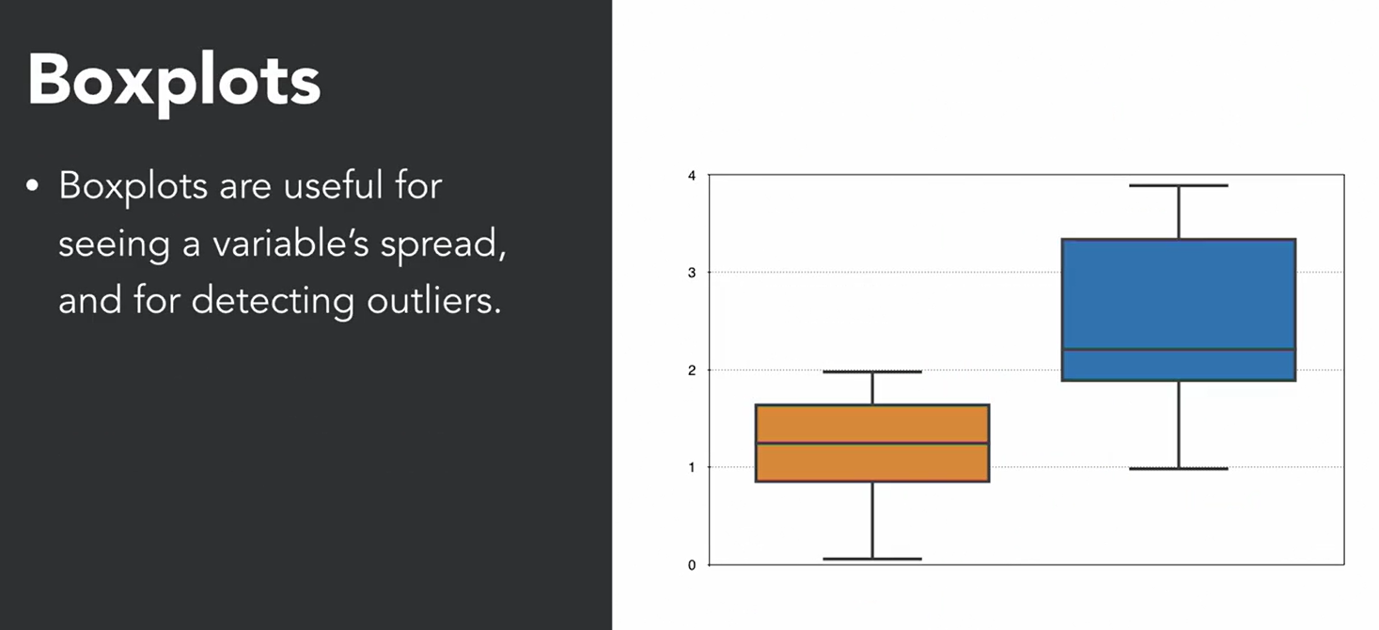

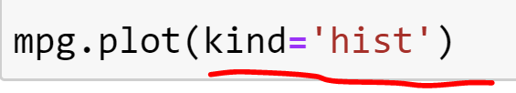

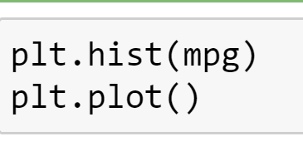

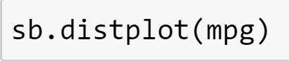

FutureWarning: `distplot` is a deprecated function and will be removed in a future version. Please adapt your code to use either `displot` (a figure-level function with similar flexibility) or `histplot` (an axes-level function for histograms).

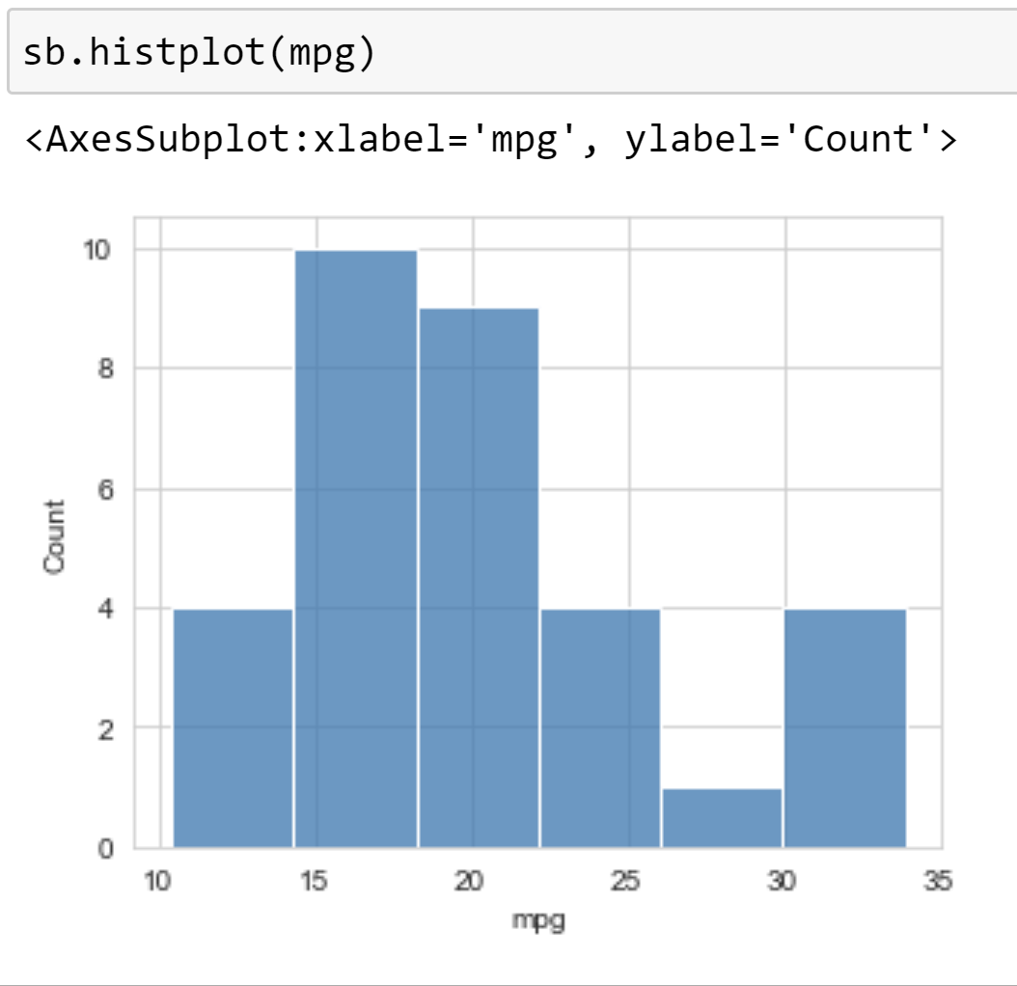

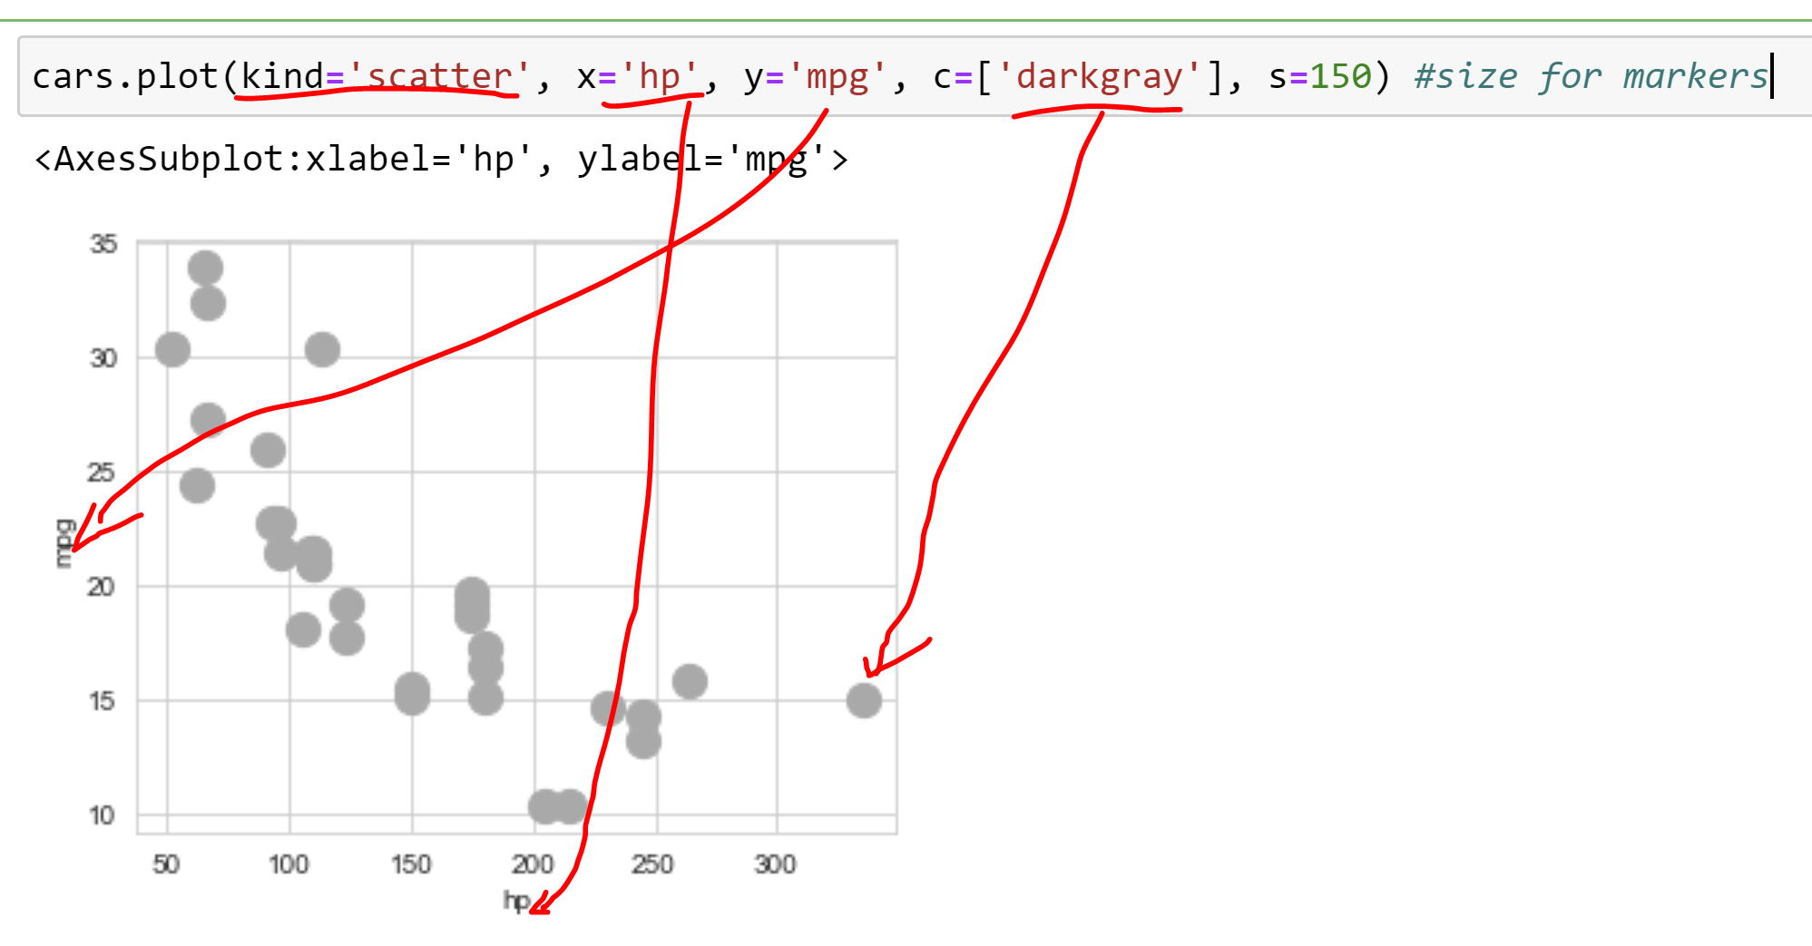

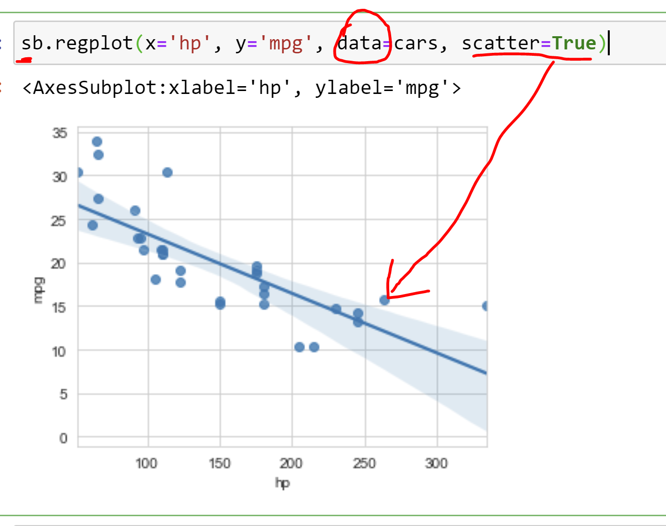

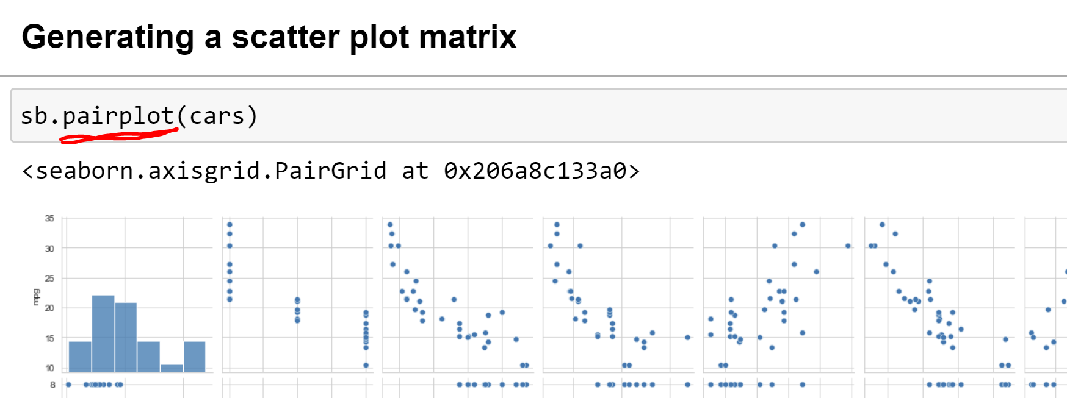

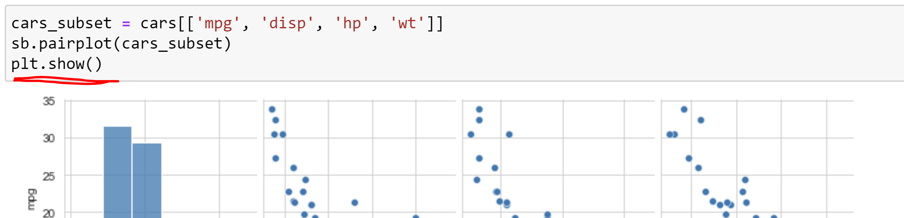

Plt.show()可有可无

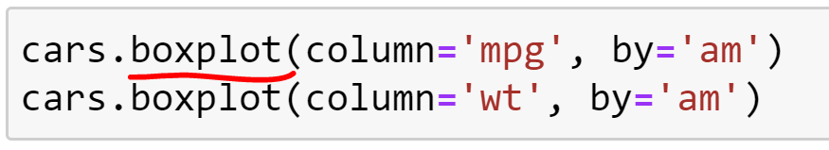



**5. Basic Math and Statistics**

5-1 Simple arithmetic

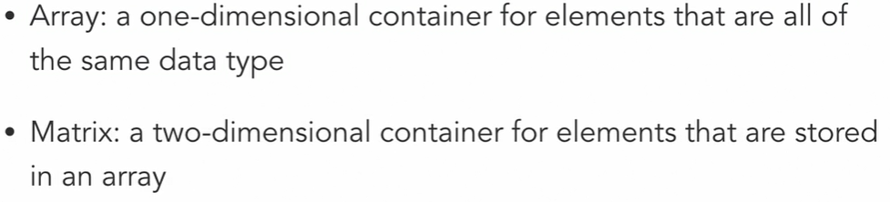



Array 的计算： + - * /

5-2 Basic linear algebra

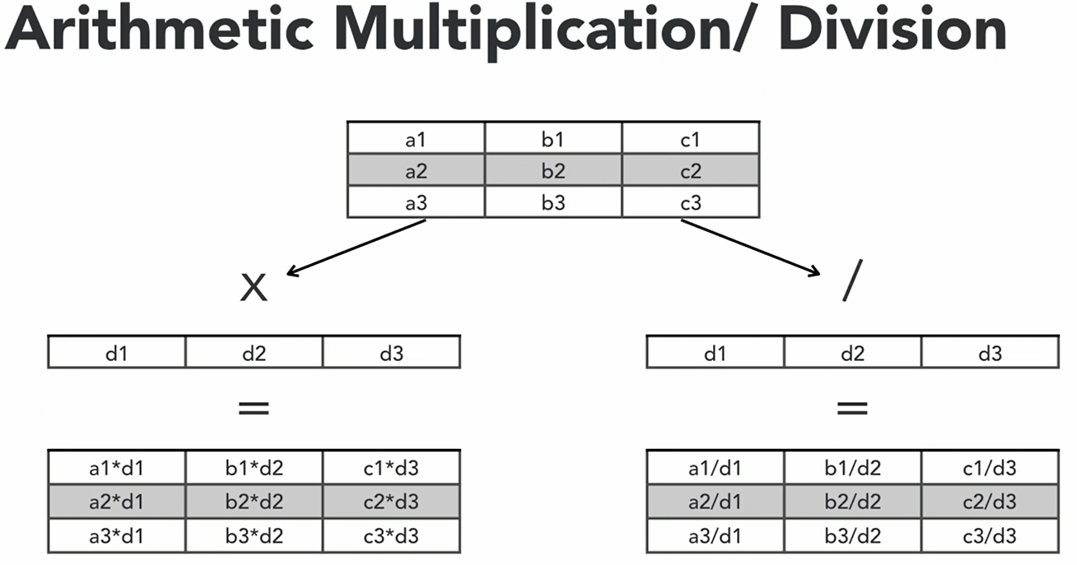

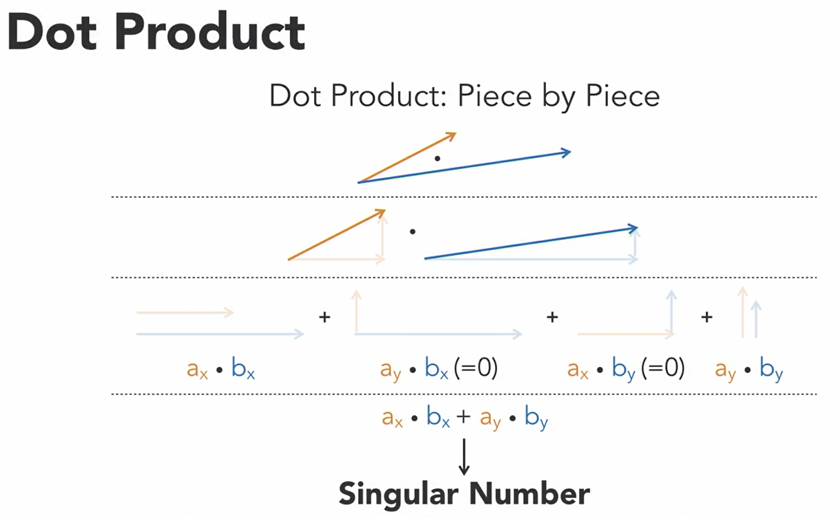

A dot product is a mathematical operation that takes two factors or a sequential units of number that have an equal number of element each and multiplies them out to generate a single number, otherwise known a scalar value.

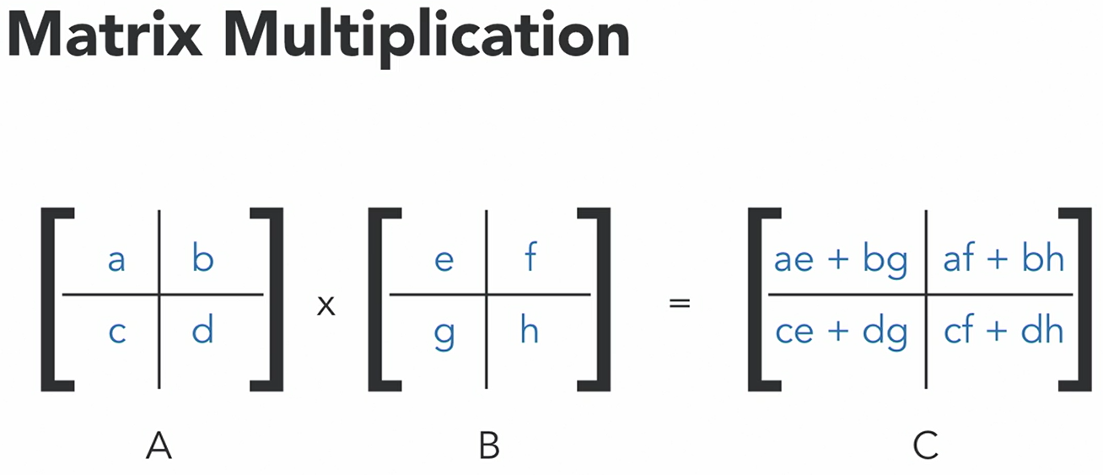

np.dot(aa,bb)

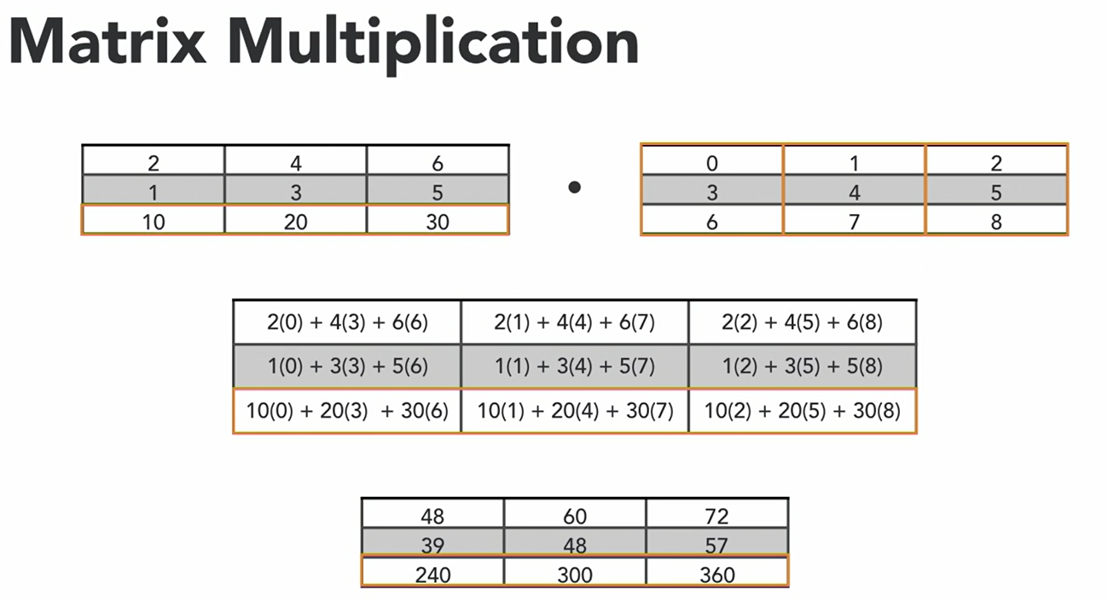

5-3 Generating summary statistics

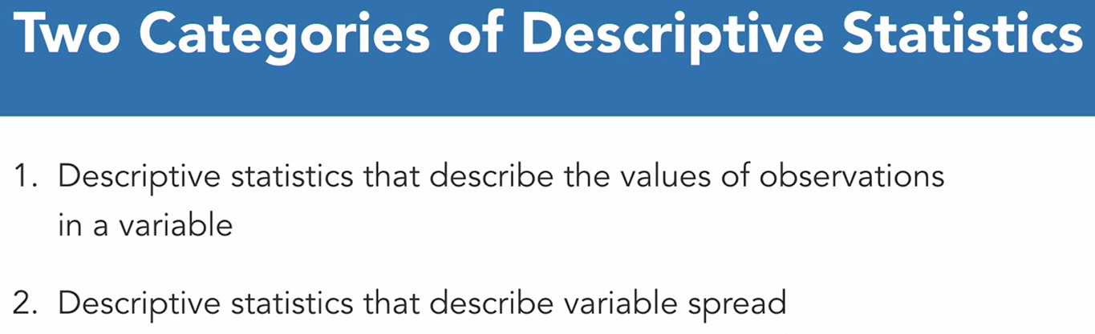

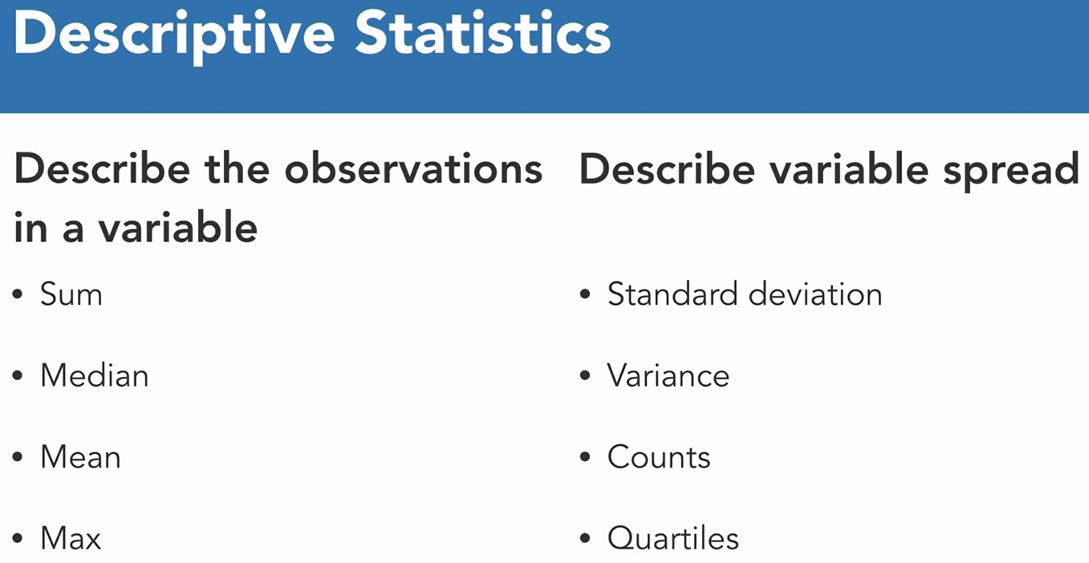

df.sum()

df.sum(axis=1) # adding up all of the values in each of the rows.

df.median()

df.mean()

df.max()

df.idxmax()



df.std()

df.var()

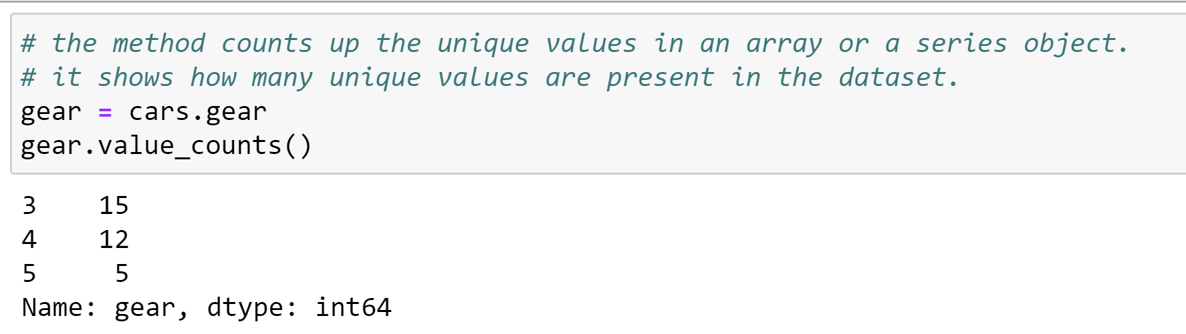

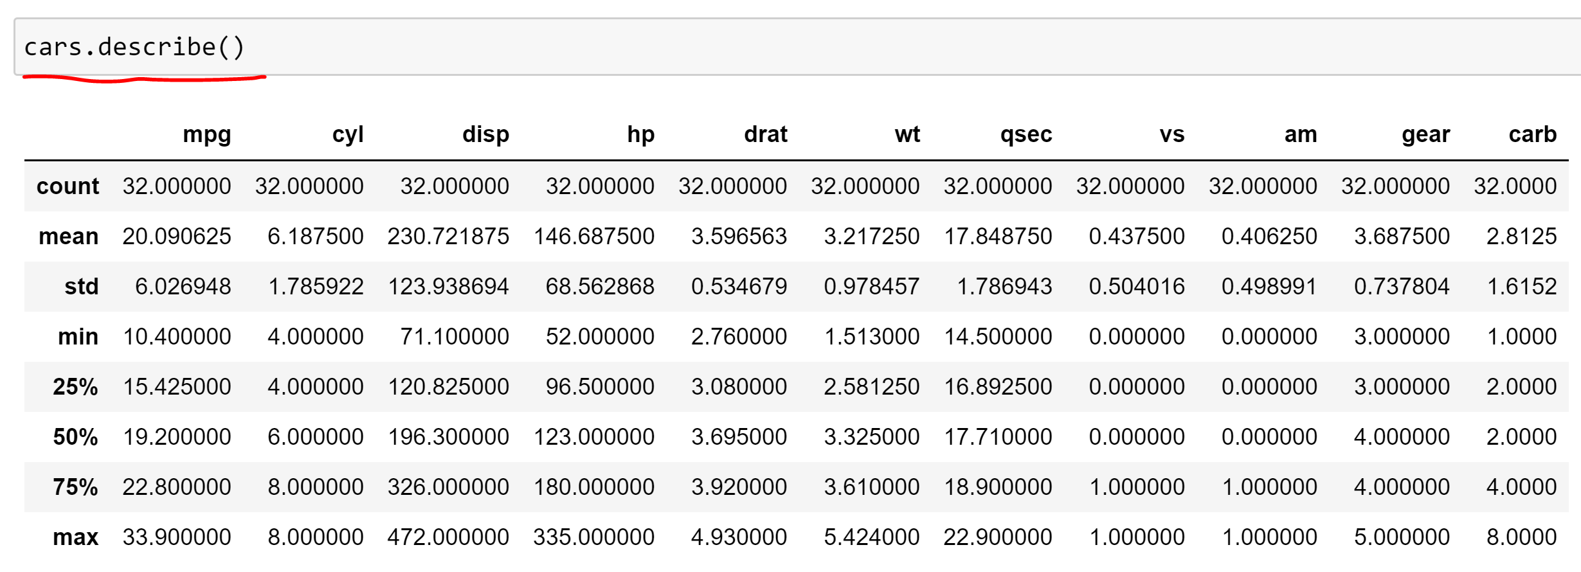

针对某一个category

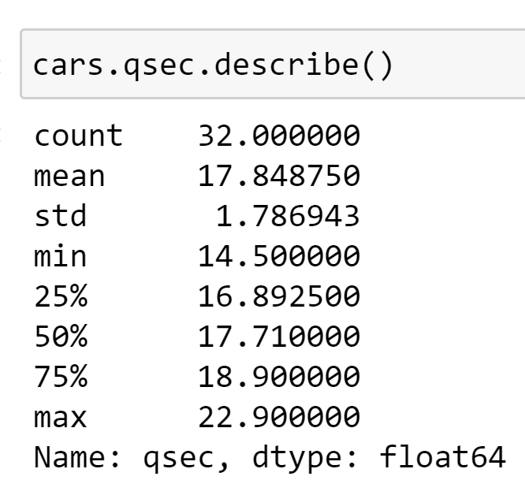

5-4 Summarizing categorical data

df.value_counts

df.groupby(‘column name’)

df.[‘column name’].dtypes()

pd.crosstab(,)

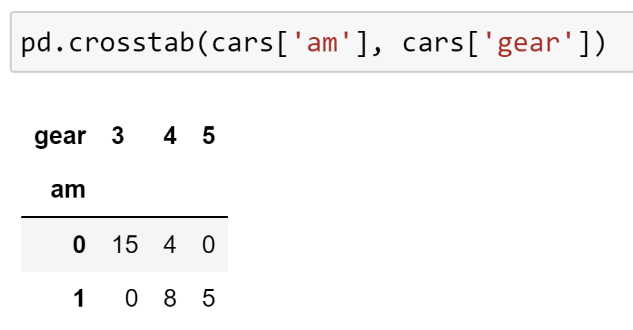

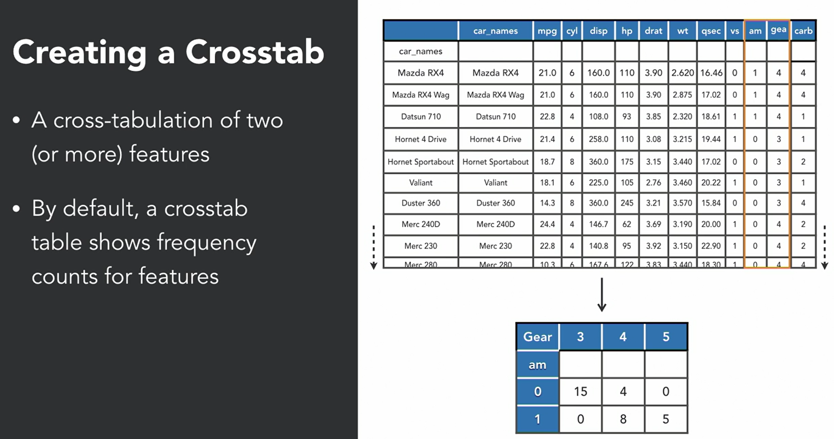’am’- manual transmission

This cross-table described to us basically about how gears are broken up with respect to automatic

（1）and manual transmission （0）.

Cars with a manual transmission, they mostly have 3 gears, but cars that have an automatic transmission are more likely to have 4 gears.

It’s basically showing a distribution of gear counts based on the type of car transmission.

5-5 Parametric correlation analysis

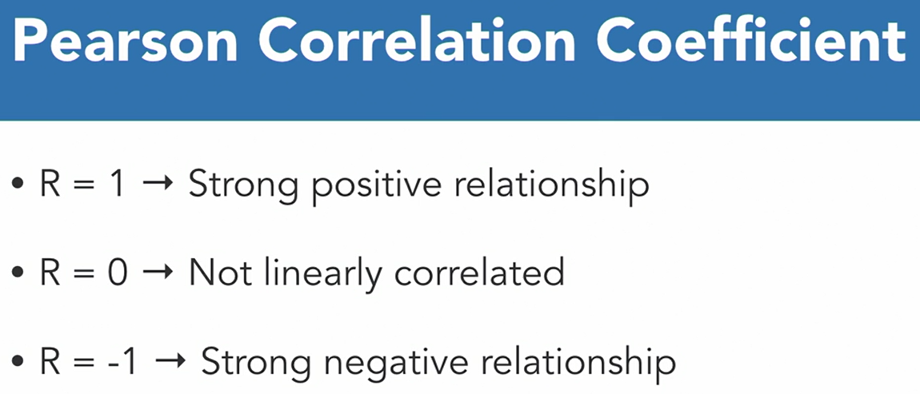

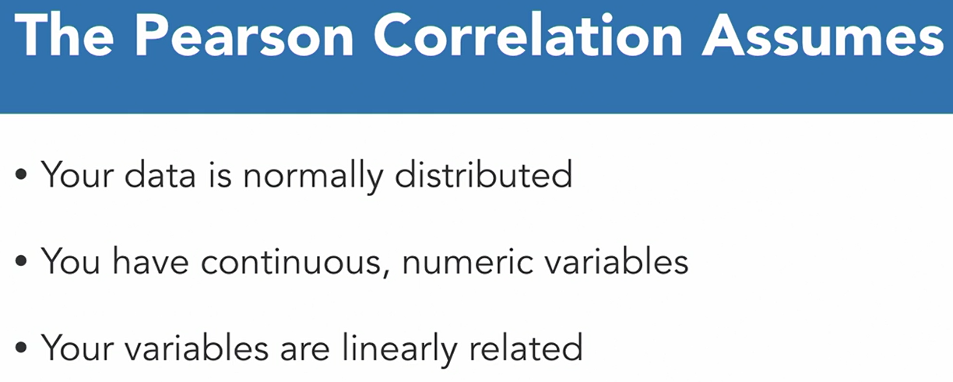

A **normally distributed** dataset is going to give you a shape like a bell curve of a histogram.

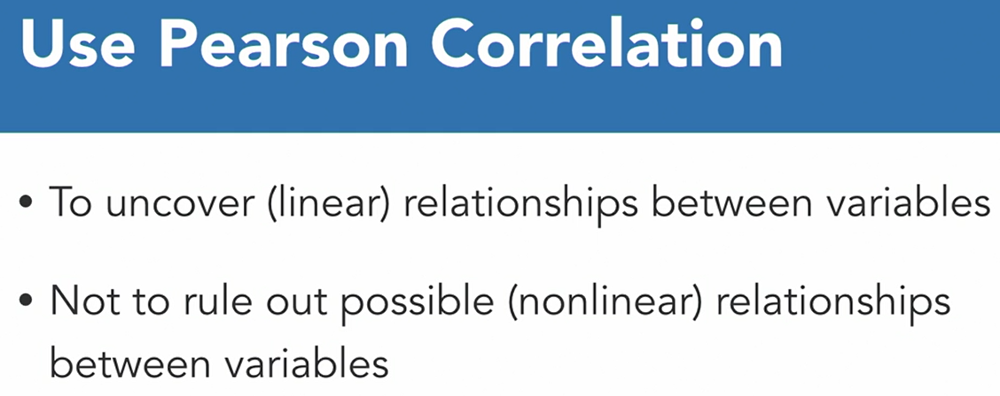

sb.pairplot(df)

Using SciPy to calculate the Pearson correlation coefficient

### Using pandas to calculate the Pearson correlation coefficient

### X = cars[['mpg', 'hp', 'qsec', 'wt']]

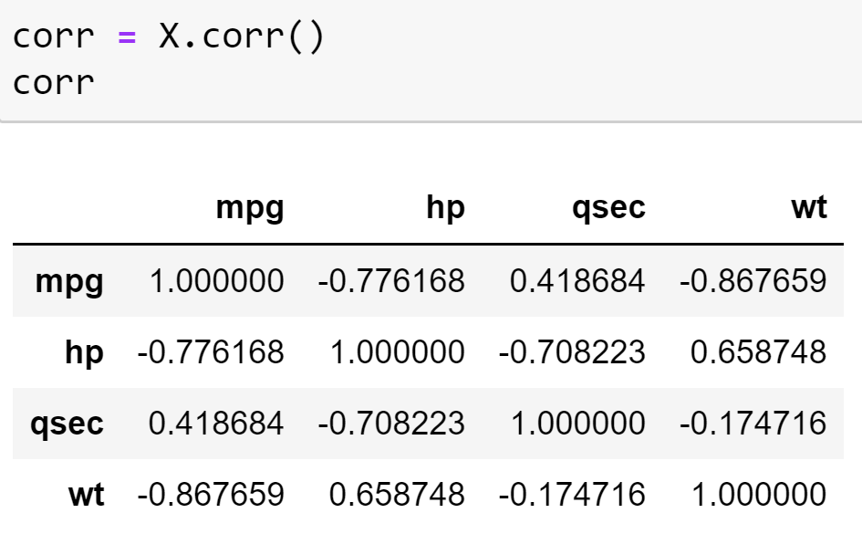

Using Seaborn to visualize the Pearson correlation coefficient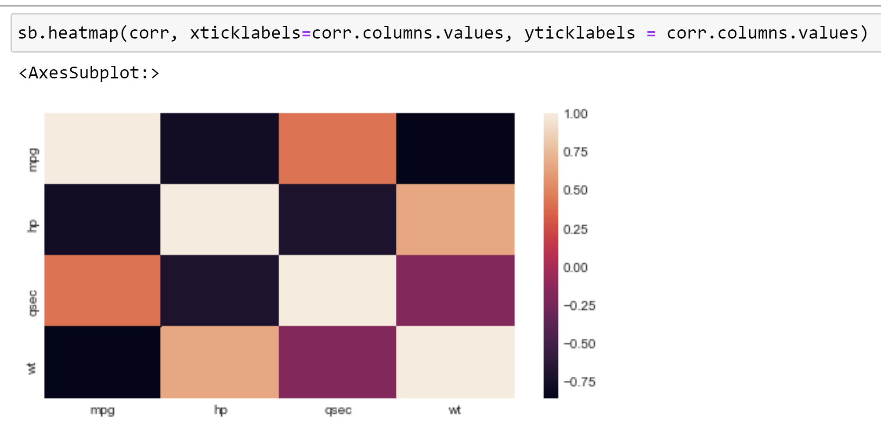

5-6 Non-parametric correlation analysis

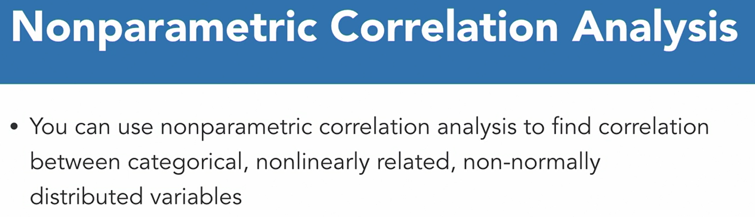

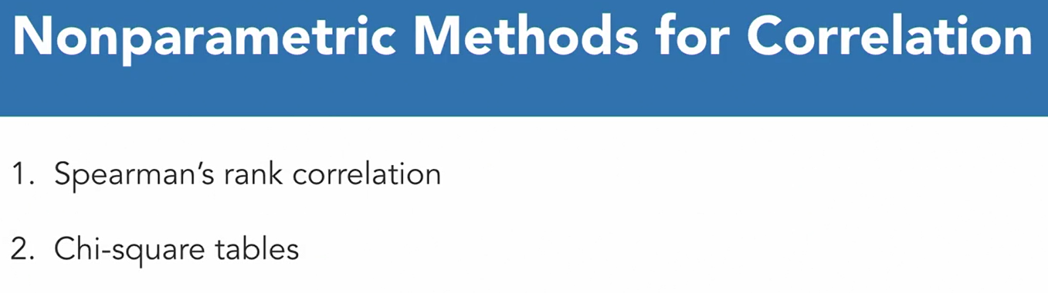

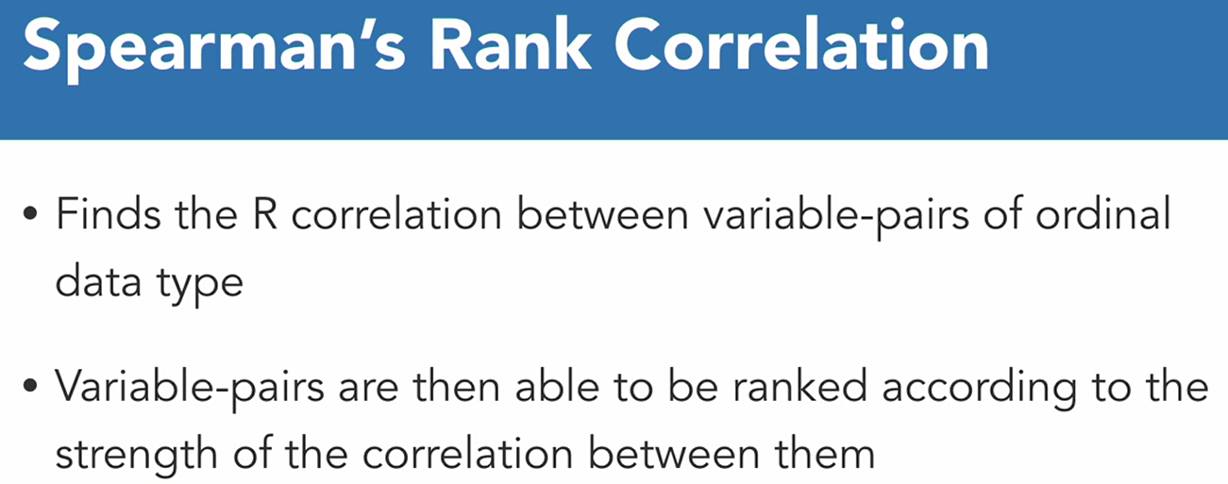

Ordinal variable is a numeric variable that’s able to be categorized.

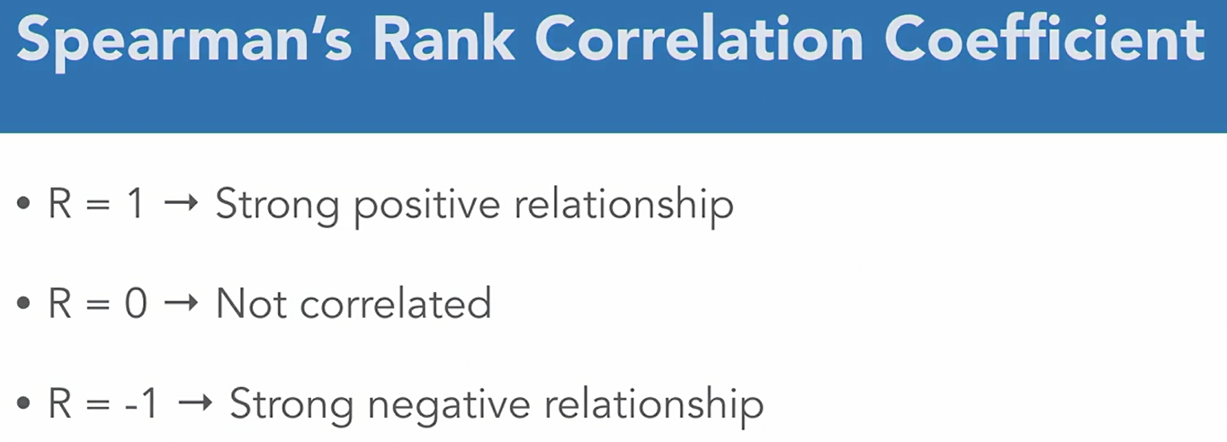

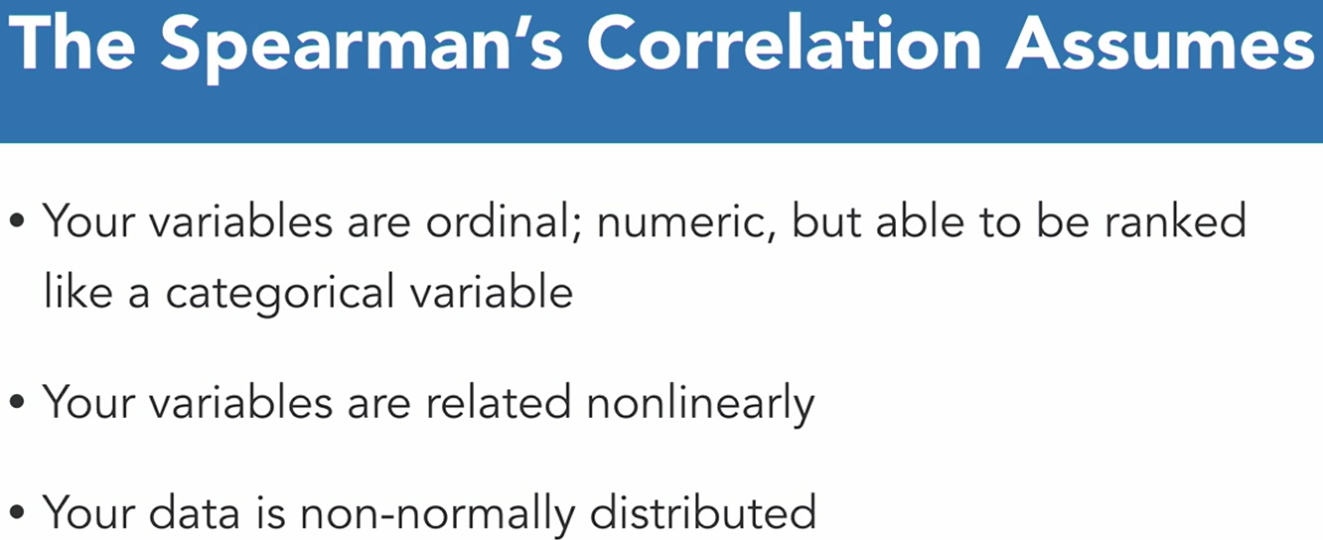

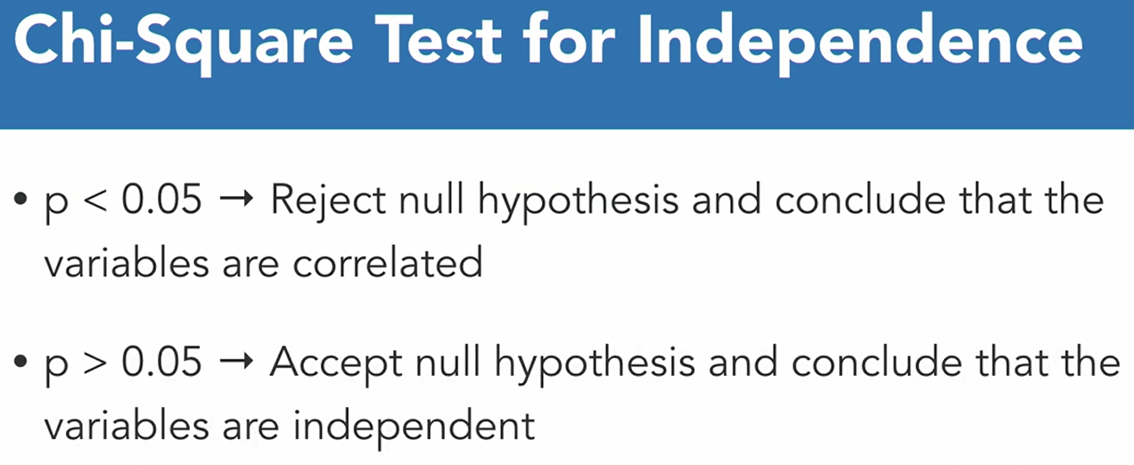

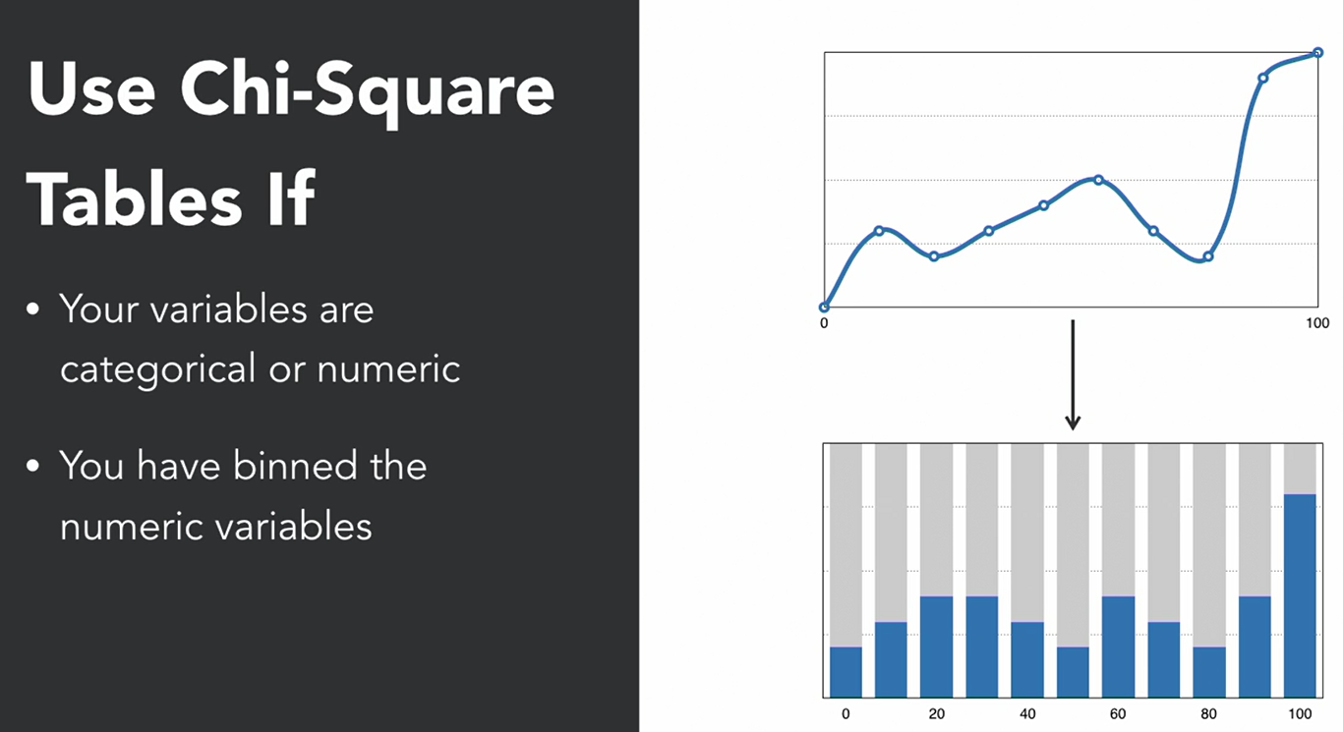

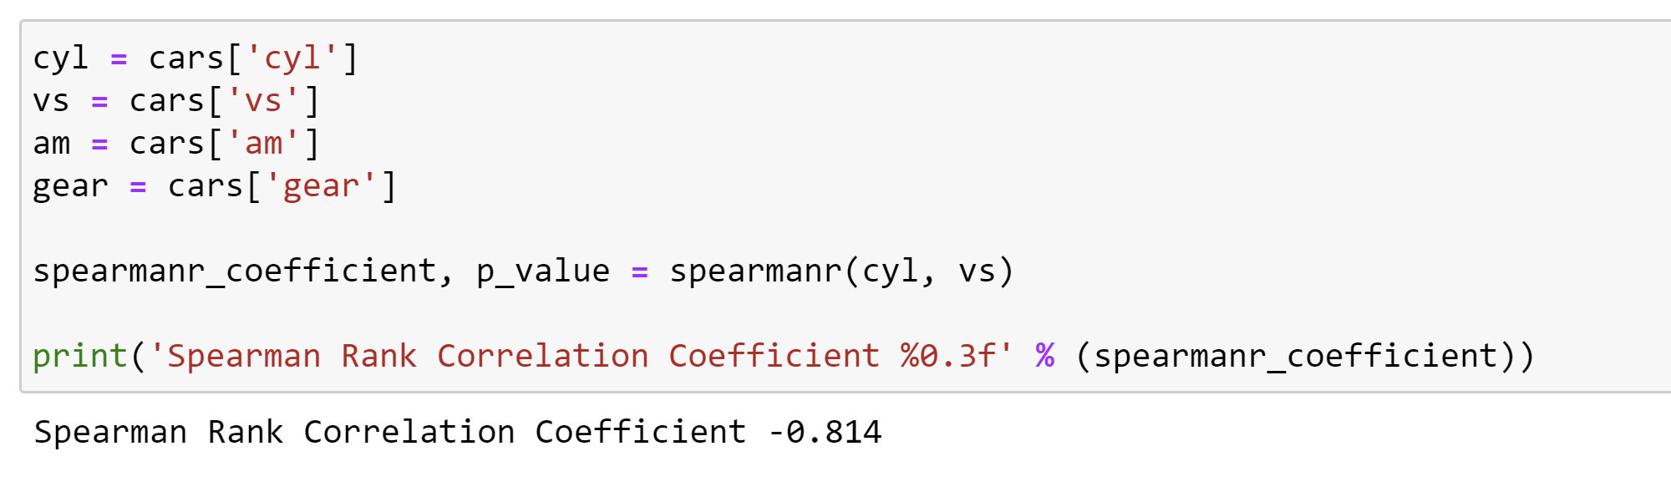

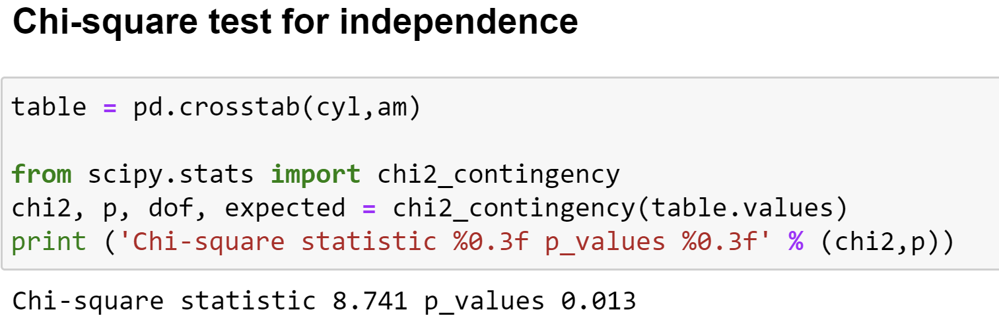

5-7 Transforming dataset distributions

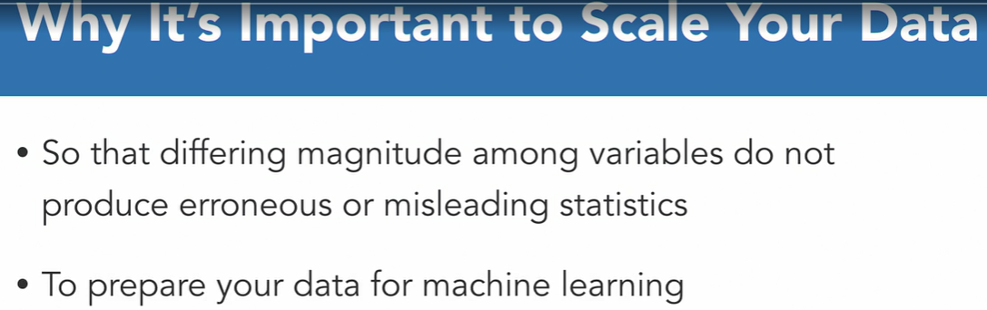

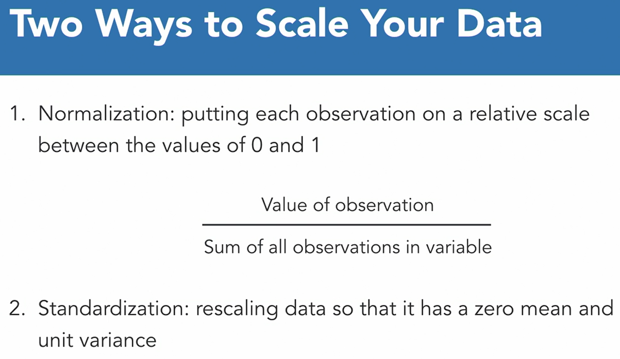 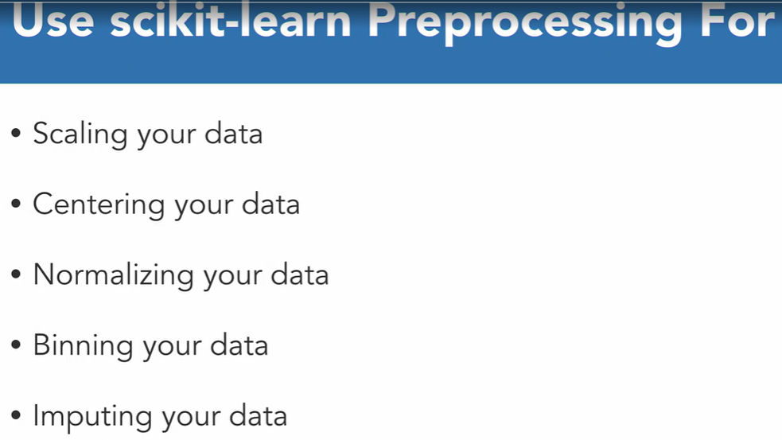

**Normalizing and transforming features with MinMaxScalar() and fit_transform()**

### MinMaxScalar() function we used to transform our variable by scaling it to a defined range. By default that range is between zero and one.

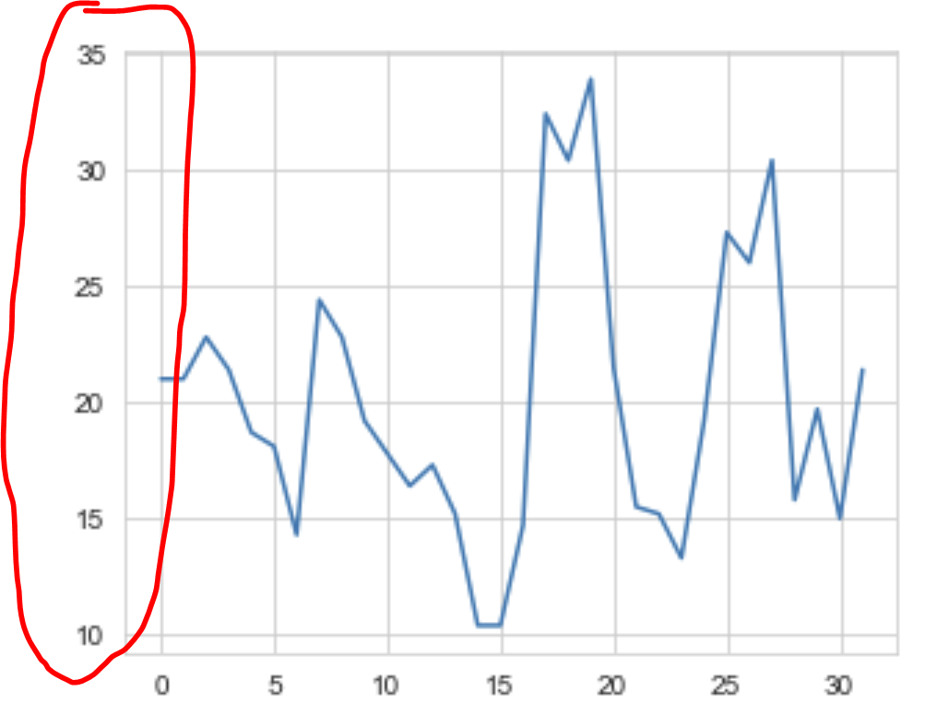 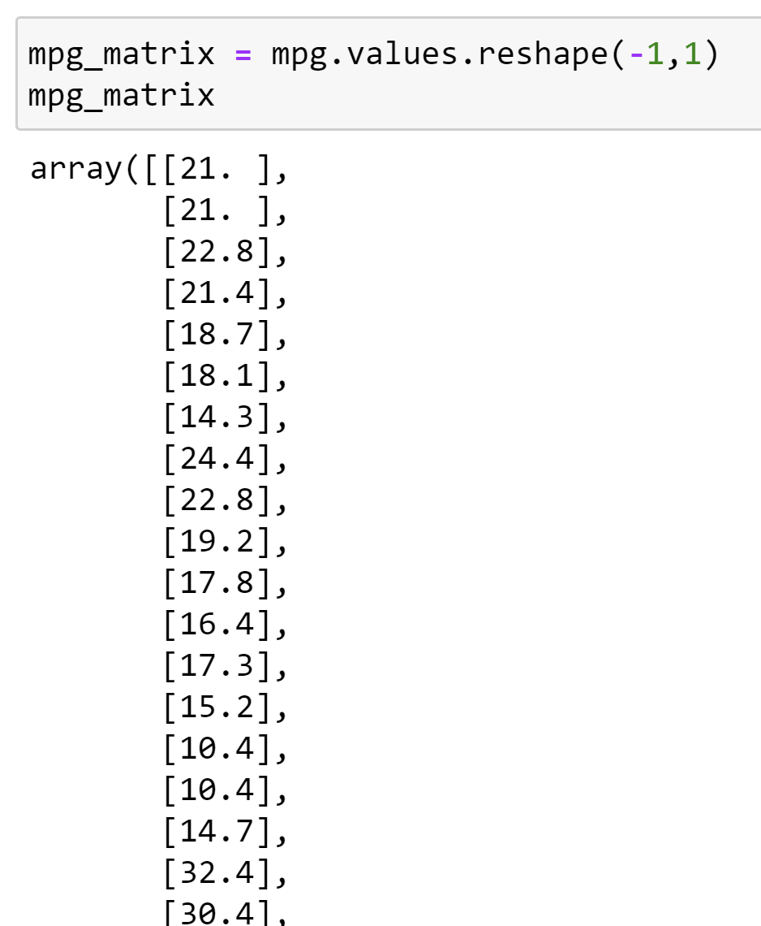

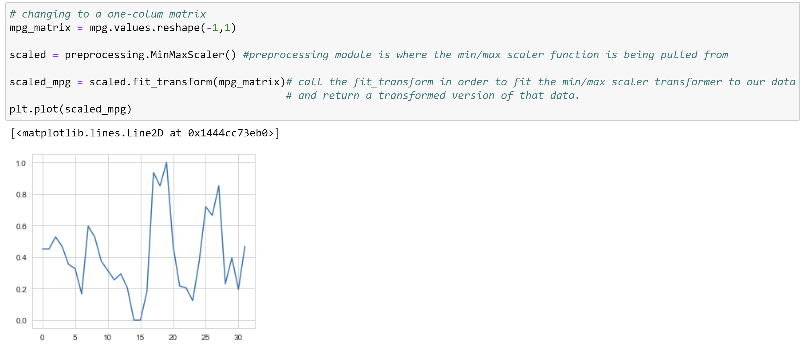

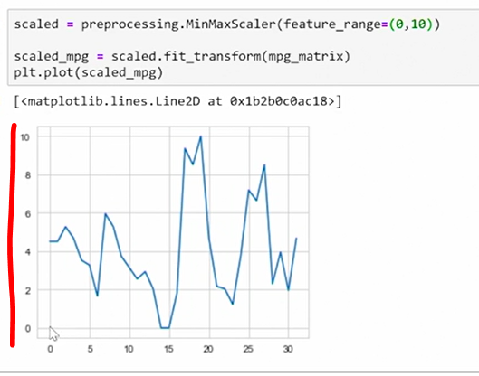

### Using scale() to scale your features

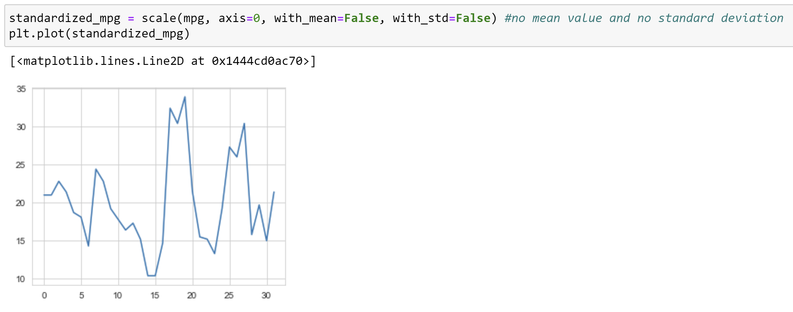

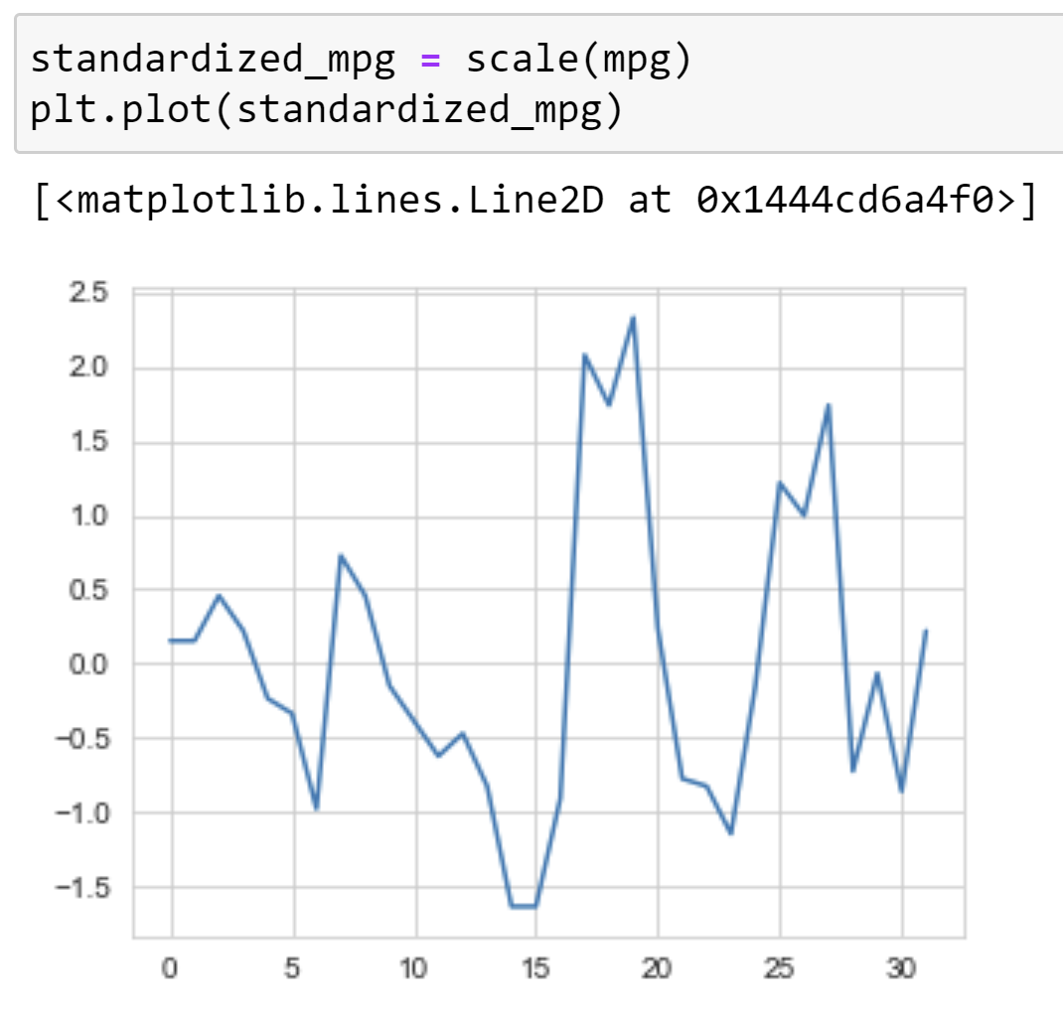

<https://www.damienfrancois.be/blog/pivot/entry.php?id=8>

5-8 Extreme value analysis for outliers

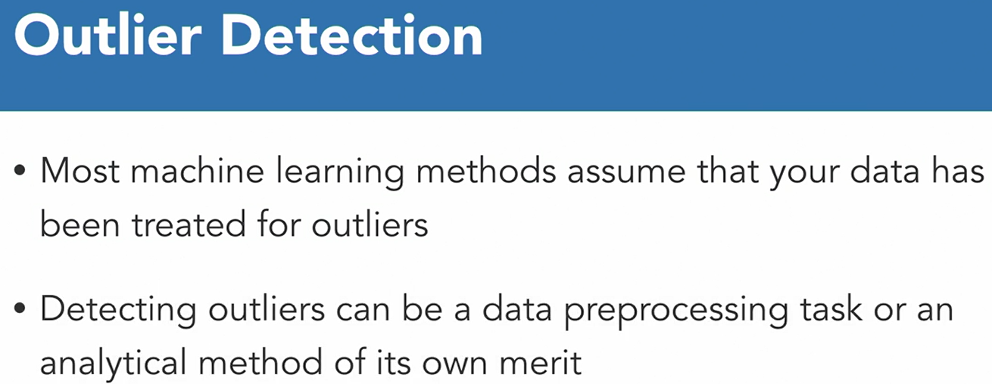

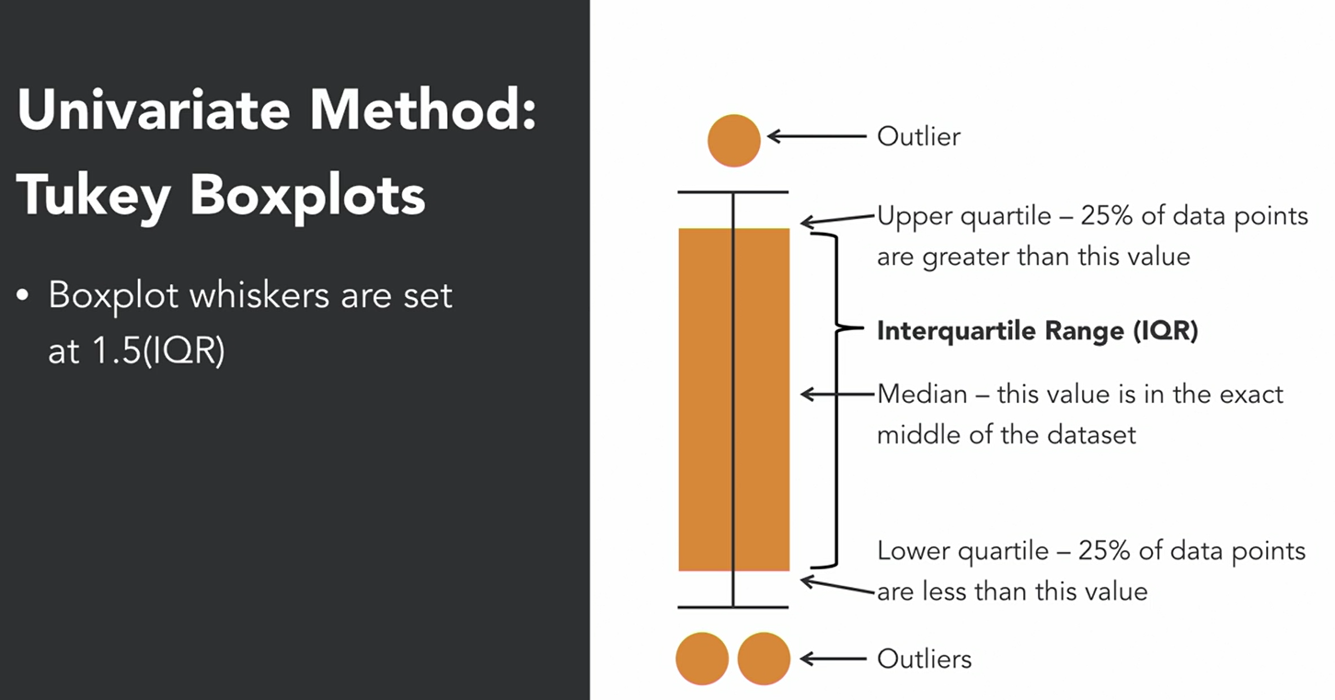

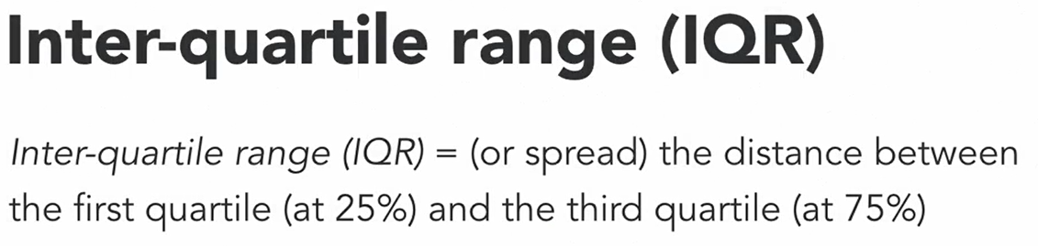

IQR = Q3 – Q1

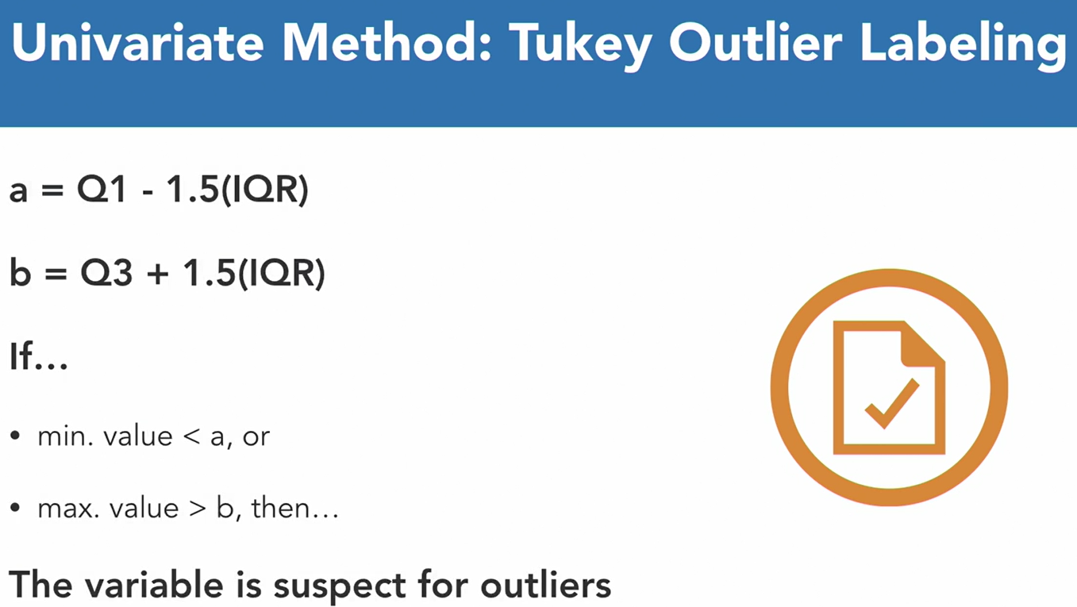

This is essentially calculating the **Tukey** outlier mathematically instead of using the box plot.

5-9 Multivariate analysis for outliers

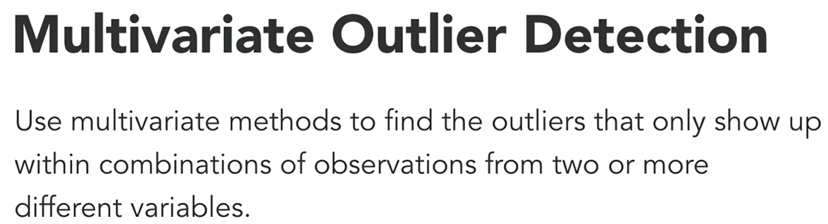

### Visually inspecting boxplots

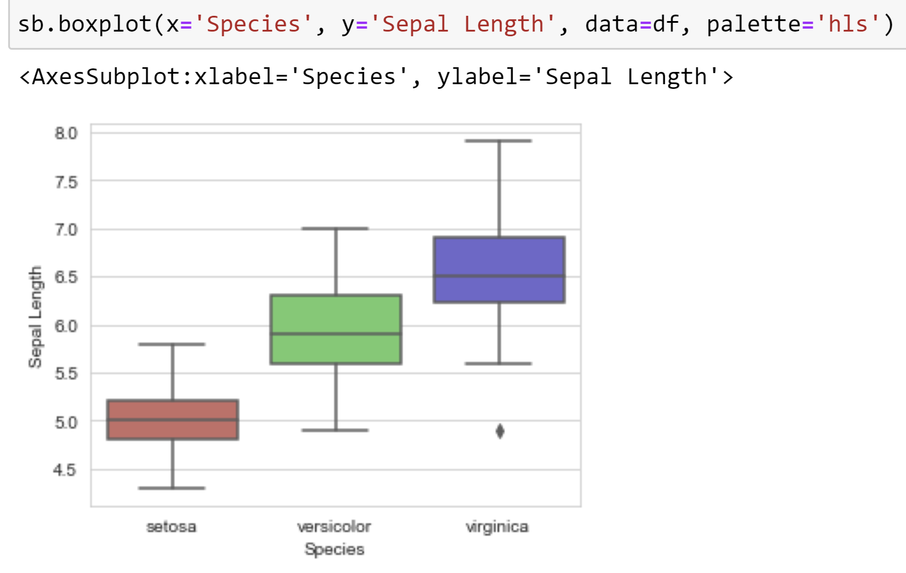

**6.Data Sourcing via Web Scraping**

6-1 BeautifulSoup object

 